Department of Veterans Affairs

Veterans Health Administration (VHA)

Office of Informatics and Analytics

Innovation Program

OneVA Pharmacy Implementation Project

System Design Document (SSD)

(CLIN #0002AC)

Business Information Technology Solutions, Inc.

3190 Fairview Park Drive, Suite 315

Falls Church, VA 22042

Task Order: VA-118-15-Q-0745



**Version 0.4**

**November 2015**

.

Revision History

Note: The revision history cycle begins once changes or enhancements are requested after the Requirements Specification Document has been baselined.

| Date | Version | Description | Author |
| --- | --- | --- | --- |
| 10/26/2015 | 0.1 | Initial Draft | Kathy Coupland |
| 10/29/2015 | 0.2 | Updated Sections 2, 3, 4, 5, and 8 | Tony Burleson |
| 11/13/2015 | 0.3 | Updated Diagrams, spelled out acronyms, and applied TJ Cope’s comments. Added Brad Fisher’s updates. | Kathy Coupland |
| 11/28/2015 | 0.4 | Updated diagram and modified two requiremetns. | Kathy Coupland |

Table of Contents

1. Introduction 10

1.1. Scope 10

1.2. User Profiles 10

1.3. Acronyms and Abbreviations 10

2. Background 12

2.1. Overview of the System 12

2.2. Overview of the Business Process 13

2.3. Overview of the Significant Requirements 13

2.3.1. Business Rules 13

2.3.2. Design Constraints 14

2.3.3. Documentation Specifications 14

2.3.4. Functional Requirements 14

3. Conceptual Design 15

3.1. Conceptual Application Design 15

3.1.1. Application Context 15

3.1.2. High-Level Application Design 16

3.2. Use Case Name: View Orders 17

3.3. Use Case Name: Dispense Local Order 17

3.4. Use Case Name: Dispense Remote Order 18

3.4.1. Application Locations 19

3.5. Conceptual Data Design 19

3.5.1. Project Conceptual Data Model 19

3.5.2. Database Information 19

3.5.3. User Interface Data Mapping 19

3.5.3.1. Application Screen Interface 19

3.5.3.2. Application Report Interface 19

3.5.3.2.1. Prescriptions we have filled for other facilities 20

3.5.3.2.2. Our prescriptions, filled by other facilities 21

3.5.3.2.3. All Remote activity 22

3.5.3.3. Unmapped Data Element 23

3.6. Conceptual Infrastructure Design 24

3.6.1. System Criticality and High Availability 24

3.6.2. Special Technology 24

3.6.3. Technology Locations 24

3.6.4. Conceptual Infrastructure Diagram 25

3.6.4.1. Location of Environments and External Interfaces 25

3.6.4.2. Conceptual Production String Diagram 26

4. System Architecture 26

4.1. Hardware Architecture 26

4.2. Software Architecture 26

4.2.1. RESTful Web Services 26

4.2.2. eMI ESB 26

4.2.3. HDR/CDS Endpoint 27

4.2.4. Remote VistA Endpoint 27

4.2.5. Sequence Diagrams 27

4.2.5.1. View Order 27

4.2.5.2. Dispense Remote Order Sequence Diagram 28

4.2.6. Design Rationale 28

4.2.7. HL7 Protocol 29

4.3. Network Architecture 29

4.4. Service Oriented Architecture / ESS 29

4.5. Enterprise Architecture 30

5. Data Design 30

5.1. DBMS Files 30

5.1.1. Refill Multiple (#52.1) of the Prescription File (#52) 30

5.1.2. Partial Multiple (#52.2) of the Prescription File (#52) 30

5.1.3. Remote Prescription Log (#52.09) 31

5.2. Non-DBMS Files 32

5.3. Data View 32

6. Detailed Design 32

6.1. Hardware Detailed Design 33

6.2. Software Detailed Design 33

6.2.1. Conceptual Design 33

6.2.1.1. Product Perspective 33

6.2.1.1.1. User Interfaces 34

6.2.1.1.2. Hardware Interfaces 34

6.2.1.1.3. Software Interfaces 34

6.2.1.1.4. Communications Interfaces 34

6.2.1.1.5. Memory Constraints 34

6.2.1.1.6. Special Operations 34

6.2.1.2. Product Features 34

6.2.1.3. User Characteristics 35

6.2.1.4. Dependencies and Constraints 35

6.2.2. Specific Requirements 36

6.2.2.1. Database Repository 36

6.2.2.2. System Features 36

6.2.2.3. Design Element Tables 36

6.2.2.3.1. Routines (Entry Points) 36

6.2.2.3.1.1. PSOORNE2 36

6.2.2.3.1.2. PSOORUT1 37

6.2.2.3.1.3. PSOROS 39

6.2.2.3.1.4. PSORRD 40

6.2.2.3.1.5. PSORREF 41

6.2.2.3.1.6. PSORREF0 42

6.2.2.3.1.7. PSORREF1 43

6.2.2.3.1.8. PSORRP 44

6.2.2.3.1.9. PSORRPA1 45

6.2.2.3.1.10. PSORRX1 46

6.2.2.3.1.11. PSORWRAP 47

6.2.2.3.1.12. PSORX1 48

6.2.2.3.2. Templates 50

6.2.2.3.2.1. PSO LM REMOTE ORDER SELECTION 50

6.2.2.3.3. Bulletins 51

6.2.2.3.4. Data Entries Affected by the Design 52

6.2.2.3.5. Unique Record(s) 52

6.2.2.3.6. File or Global Size Changes 52

6.2.2.3.6.1. Global 52

6.2.2.3.6.2. Files 53

6.2.2.3.7. Mail Groups 56

6.2.2.3.8. Security Keys 56

6.2.2.3.9. Options 56

6.2.2.3.9.1. Pharmacy Remote Prescription Manager Options 56

6.2.2.3.10. Protocols 58

6.2.2.3.11. Remote Procedure Call (RPC) 65

6.2.2.3.12. Constants Defined in Interface 65

6.2.2.3.13. Variables Defined in Interface 65

6.2.2.3.14. Types Defined in Interface 66

6.2.2.3.15. GUI 66

6.2.2.3.16. GUI Classes 66

6.2.2.3.17. Current Form 66

6.2.2.3.18. Modified Form 66

6.2.2.3.19. Components on Form 66

6.2.2.3.20. Events 67

6.2.2.3.21. Methods 67

6.2.2.3.22. Special References 67

6.2.2.3.23. Class Events 67

6.2.2.3.24. Class Methods 67

6.2.2.3.25. Class Properties 67

6.2.2.3.26. Uses Clause 67

6.2.2.3.27. Forms 68

6.2.2.3.28. Functions 68

6.2.2.3.29. Dialog 70

6.2.2.3.30. Help Frame 70

6.2.2.3.31. HL7 Application Parameter 71

6.2.3. HL7 Protocols 71

6.2.4. HL7 Sender and Receiver Applications 73

6.2.5. Sender and Receiver Logical Links 74

6.2.5.1.1. HL7 Logical Link 77

6.2.5.1.2. COTS Interface 78

6.3. Network Detailed Design 78

6.4. Security and Privacy 78

6.4.1. Security 78

6.4.1.1. Secure Sockets Layer (SSL) 78

6.4.1.2. Authentication and Authorization 79

6.4.1.3. Remote Prescription Locking 79

6.4.2. Privacy 79

6.5. Service Oriented Architecture / ESS Detailed Design 80

6.5.1. Service Description for <Consumed Service Name> 80

6.5.2. Service Design for <Provided Service Name> 80

6.5.2.1. Introduction 80

6.5.2.1.1. Purpose and Scope of Service 80

6.5.2.1.2. Links to Other Documents 80

6.5.2.2. Service Details 80

6.5.2.2.1. Service Identification 80

6.5.2.2.2. Service Versions 82

6.5.2.2.3. Summary of Design and Platform Details 82

6.5.2.2.3.1. SOA Pattern(s) Implemented 82

6.5.2.2.3.2. COTS Platform vendor names and versions for hosting platform 82

6.5.2.3. Dependencies 82

6.5.2.4. Service Design Details 82

6.5.2.4.1. Interface Technical Specs 82

6.5.2.4.1.1. Service Invocation Type 82

6.5.2.4.1.2. Service Interface Type 82

6.5.2.4.1.3. Service Name 83

6.5.2.4.1.4. Interface 83

6.5.2.4.1.5. End Points 83

6.5.2.4.1.6. Operations or Methods 83

6.5.2.4.1.7. Message Schemas 83

6.5.2.4.2. Information Model 83

6.5.2.4.2.1. Class Diagram and Description of Entities Involved 83

6.5.2.4.2.2. Mappings from ELDM to Standards Based Schemas 84

6.5.2.4.3. Behavior Model (AKA Use Case Realization) 84

6.5.2.4.3.1. Use Cases (Use Case Model) 84

6.5.2.4.3.2. Interaction Diagrams 84

6.5.2.5. Gap Analysis 84

6.5.2.5.1. Variances from Enterprise Target Architecture 84

6.5.2.5.2. Variances from SLDs 85

6.5.2.5.3. Variances from Standards and Policies 85

6.5.2.5.4. Justification for Exceptions and Mitigation 85

7. External System Interface Design 85

7.1. Interface Architecture 85

7.2. Interface Detailed Design 85

7.3. Acknowledgement Codes 85

7.4. Order Control Codes 86

7.5. Remote Prescription Query Transaction 86

7.5.1. Remote Prescription Query Request 86

7.5.2. Sample QBP^Q13 Request 87

7.5.3. Remote Prescription Query Response 87

7.5.4. Sample KTB^K13 Response 89

7.6. Remote Prescription Dispense Transaction 89

7.6.1. Remote Description Dispense Request 89

7.6.2. Remote Description Dispense Response 91

8. Human-Machine Interface 93

8.1. Interface Design Rules 93

8.2. Inputs 93

8.3. Outputs 93

8.4. Navigation Hierarchy 93

8.4.1. Prescription Display 93

9. Attachment A – Approval Signatures 96

A.1. Identification of Technology and Standards 97

A.2. Constraining Policies, Directives and Procedures 97

A.3. Requirements Traceability Matrix 97

A.4. Packaging and Installation 97

A.5. Design Metrics 97

Table of Figures

Figure 1: OneVA Pharmacy System Design 13

Figure 2: Application Architectural Diagram 15

Figure 3: High-level Context Diagram 16

Figure 4: Remote Report Content Example 21

Figure 5: Remote Report Content Example 22

Figure 6: Remote Report Content Example 23

Figure 7: Sample Conceptual Networks and Environments 26

Figure 8: Conceptual Production String Diagram 26

Figure 9: View Order Sequence diagram 27

Figure 10: Dispense Remote Order Sequence diagram 28

Figure 11: Example of Configuration of a Protocol to handle QBP-Q13 Events 71

Figure 12: Example of Configuration of a Protocol to handle QBP-Q13 Events 72

Figure 13: Example of Configuration of a Protocol to handle QBP-Q13 Events 72

Figure 14: Example of Configuration of a Protocol to handle QBP-Q13 Events 73

Figure 15: Receiving HL7 Application Configuration 73

Figure 16: Sending HL7 Application Configuration 74

Figure 17: Example of Configuration of Logical Links 74

Figure 18: Example of Configuration of Logical Links 75

Figure 19: Example of Configuration of Logical Links 75

Figure 20: Example of Configuration of Logical Links 76

Table of Tables

Table 1: Acronym & Abbreviation Table 10

Table 2: MLLP HL7 Endpoint Messages 26

Table 3: Global Placement and Protection 53

Table 4: Files 53

Table 5: REFILL Sub file (#52.1) 53

Table 6: PARTIAL FILL sub file (#52.2) 54

Table 7: Remote Prescription Log (#52.09 54

Table 8: Acknowledgement Codes 85

Table 9: Order Control Codes 86

Table 10: Remote Prescription Query Request 86

Table 11: QPD Field Description and Commentary 87

Table 12: PID Field Description and Commentary 87

Table 13: RCP Field Description and Commentary 87

Table 14: Remote Prescription Query Response 88

Table 15: RCP Field Description and Commentary 88

Table 16: Remote Description Dispense Request 89

Table 17: PID Field Description and Commentary 90

Table 18: ORC Field Description and Commentary 90

Table 19: RXO Field Description and Commentary 91

Table 20: Remote Description Dispense Response 91

Table 21: RXD Field Description and Commentary 92

# Introduction

Leadership at the Department of Veterans Affairs (VA) initiated the OneVA Pharmacy Implementation project to enhance and integrate the OneVA Pharmacy prototype into VistA. The OneVA Pharmacy module will provide the Department of Veterans Health Administration (VHA) the capability to allow Veterans travelling across the United States to refill their active VA prescription at any VA Pharmacy regardless of where the prescription originated. The module expands available pharmacy information in VistA to pharmacists providing direct access to any active and refillable prescription from any VA Healthcare System. The OneVA Pharmacy Implementation project modifies the existing prototype software to expand its current capability and includes the development of documentation to support a national rollout in March 2016.

The OneVA Pharmacy module and this implementation provides a foundation to build and extend new capabilities to the Veteran, who are better served by integrating virtual care into pharmacies, using technology to close the gap between the previous quality of information, and the Veteran's level of engagement. A well-designed OneVA Pharmacy builds upon the history of the VHA, and advances in modern technology to allow Veterans to take a more active role in their own health care.

## Scope

This System Design Document (SDD) will define the high level design for the OneVA Pharmacy Implementation Project objectives. It defines and describes system components, architectural views, system constraints, and design rationale.

## User Profiles

The user profile of the OneVA Pharmacy module are those users, specifically pharmacists, that use the Pharmacy [PSO LM BACKDOOR ORDERS] menu to dispense prescriptions.

## Acronyms and Abbreviations

The following table provides the list of acronyms used throughout the document along with their descriptions.

Table : Acronym & Abbreviation Table

| Acronym/Abbreviation | Description |
| --- | --- |
| ADT | Admission Discharge Transfer |
| AITC | Austin Information Technology Center |
| API | Application Programming Interface |
| BITS | Business Information Technology Solutions, Inc. |
| CDS | Clinical Data Services |
| CLIN | Contract Line Item Number |
| DFN | Data File Number |
| DHCP | Dynamic Host Configuration Protocol |
| DoD | Department of Defense |
| EHR | Electronic Health Record |
| eMI | Enterprise Messaging Infrastructure |
| ESB | Enterprise Service Bus |
| HDR | Health Data Repository |
| HL7 | Health Level 7 |
| ICN | Integration Control Number |
| IOC | Initial Operating Capability |
| IT | Information Technology |
| MLLP | Minimal Lower Layer Protocol |
| MUMPS | Massachusetts General Hospital Utility Multi Programming System |
| MVI | Master Veteran Index |
| OIA | Office of Informatics and Analytics |
| PMAS | Project Management Accountability System |
| PSO | Outpatient Prescription Pharmacy |
| [PSO LM BACKDOOR ORDERS] | Patient Prescription Processing |
| PWS | Performance Work Statement |
| RDNG | IBM Rational DOORS Next Generation |
| REST | Representational State Transfer |
| RSD | Requirements Specification Document |
| RTM | Requirements Traceability Matrix |
| SDD | System Design Document |
| SME | Subject Matter Expert |
| SOA | Service Oriented Architecture |
| TRM | Technical Reference Model |
| VA | Department of Veterans Affairs |
| VHA | Department of Veterans Health Administration |
| VistA | Veterans Health Information Systems and Technology Architecture |

# Background

## Overview of the System

The overall system design is partitioned into two main components. They are:

1. VistA Server
2. Enterprise Messaging Infrastructure (eMI) Enterprise Service Bus (ESB)

The VistA Server is the user interface where a pharmacist will use the “Patient Prescription Processing [PSO LM BACKDOOR ORDERS]” menu option to query for and refill, patient’s active and refillable prescriptions; local and remote. The eMI ESB receives requests from VistA to query the Health Data Repository/Clinical Data Service (HDR/CDS) for a patient’s active and refillable remote prescriptions. The VistA Server and the eMI ESB communicate with each other using Health Level 7 (HL7) v2.5.1 over Minimal Layer Protocol (MLLP) and via Representational State Transfer (RESTful) web services. Communication to the HDR/CDS will also be via RESTful web services.

The following figure displays the OneVA Pharmacy system design approach.

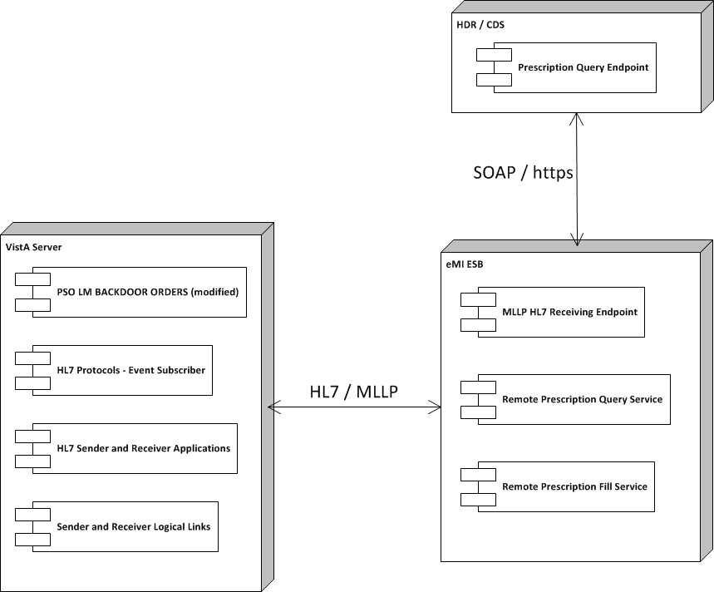Figure : OneVA Pharmacy System Design

## Overview of the Business Process

OneVA Pharmacy provides VistA the functionality to allow pharmacists to refill a prescription at any VA pharmacy location. It decrements the patients number of remaining refill balance at the originating pharmacy and manages controlled substances by displaying a message that a controlled substance cannot be refilled outside of the originating pharmacy. The proof-of-concept software will be modified to utilize a middleware model that meets the OneVA Technical Reference Model (TRM) list of approved technologies.

## Overview of the Significant Requirements

### Business Rules

Business rules are a high-level functionality condition that the system must support in order to complete the business of the organization. Business rules describe the operations, definitions, and constraints that apply to an organization. The high-level overview of the business rules for OneVA Pharmacy Implementation project includes filtering on only ‘active’ prescriptions with one or more refills remaining and the date of the next refill is no earlier than one week. The prescription cannot be a controlled substance and the patient must be registered in one or more VistAs.

The detailed business rules for the OneVA Pharmacy Implementation project can be found on the VAs installation of the IBM Rational DOORS Next Generation Platform (RDNG) platform under the Pharmacy project in the OneVAPharm team area.

### Design Constraints

Design constraints mandate design decisions that the system must support in order to complete the business of the organization. The high-level overview of the design constraints for the OneVA Pharmacy Implementation project includes using the VistA routine ‘Patient Prescription Processing’ [PSO LM BACKDOOR ORDERS] to access local patient information; HDR/CDS will be used display a medication profile; and the eMI and the VistA Dynamic Host Configuration Protocol (DHCP) HL7 interface for information exchange between VistA systems.

The details for the all design constraints for the OneVA Pharmacy Implementation project can be found on the VAs installation of the IBM Rational DOORS Next Generation Platform (RDNG) platform under the Pharmacy project in the OneVAPharm team area.

### Documentation Specifications

The goal of the ‘Documentation Specifications’ is to ensure necessary documentation is developed according to standard, including the VA Certification and Accreditation process (when applicable). The product documentation includes but is not limited to an Installation Guide, Operations and Maintenance Plan, Technical Manual, User Guide, and Training Manual. Project Management Accountability System (PMAS) Documentation for the One VA Pharmacy Implementation project includes, but is not limited to Risk Issue Log, Requirements Specification Document (RSD), System Design Document (SDD), Initial Operating Capability (IOC) Documentation, Master Test Plan, IOC Site Memorandum of Understanding, Primary Developer Checklist, Secondary Developer Checklist, Requirements Traceability Matrix (RTM), Acceptance Criteria Plan, IOC Entry Request and Exit Summary, Lesson Learned, Contractor Staff Roster, and Training Plan.

The details for all documents required for the OneVA Pharmacy Implementation project can be found on the VAs installation of the IBM Rational DOORS Next Generation Platform (RDNG) platform under the Pharmacy project in the OneVAPharm team area.

### Functional Requirements

A requirement specifies functions that the application should be able to perform and constraints on application performance. The high-level overview functional specifications for OneVA Pharmacy Implementation project includes displaying the Medication Profile for a patient from all other facilities, capability to refill full or partial active prescription for a patient at remote site other than the site the prescription originated frame, dispense local refills as currently designed, generate an Rx label, and generate new reports.

The functional requirements are detailed in the OneVA Pharmacy Implementation RSD which can be found on the VAs installation of the IBM Rational DOORS Next Generation Platform (RDNG) platform under the Pharmacy project in the OneVAPharm team area.

# Conceptual Design

## Conceptual Application Design

The software architecture follows the peer-to-peer architectural model, where one VistA node sends and receives data to and from another VistA node. The system utilizes the ESB model providing message routing and coordination of multiple services to view a patient’s prescription record and modify that record in remote VistA systems.

### Application Context

The following diagram displays the VistA application and how it will exist within the design of the ESB model.

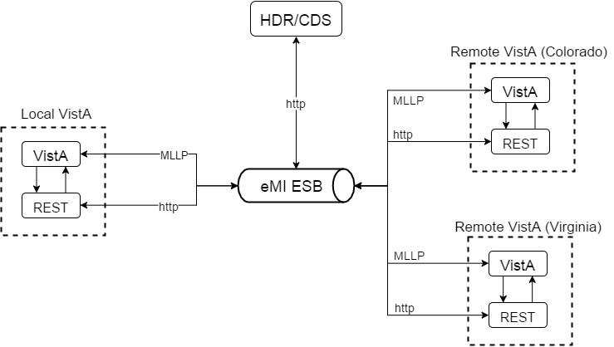

Figure : Application Architectural Diagram

The entities displayed in the Application Architecture Diagram are explained as follows:

* VistA is the user interface for initiating prescription queries and requesting prescription refills from remote VistAs.
* VistA RESTful Web Services are a set of RESTful web services that use Intersystem Cache Global Application Programming Interface (API) to read and write data to the VistA data store and to call the Massachusetts General Hospital Utility Multi Programming System (MUMPS) functions.
* eMI ESB is the messaging component to handle MLLP HL7 endpoints, RESTful endpoints to VistA, and the HDR/CDS.

### High-Level Application Design

The High-Level Application Design identifies the major components of the application and the relationships of the major application components to each other. Use cases are being used in this SDD to document the logical application design for the OneVA Pharmacy Implementation project.

The following use cases have the pre-condition that the patient is known and registered in one or more VistAs.

Note: The act of registering a patient in VistA triggers an Admission Discharge Transfer (ADT) registration message to be sent to the Master Veteran Index (MVI) located in the Austin Information Technology Center (AITC). For each new patient, the MVI creates and assigns an Integration Control Number (ICN) and sends this number among other information to the initiating VistA in response to the ADT message. Further the MVI, stores and correlates the local VistA Patient Data File Numbers (DFNs) with the national ICN. One national patient ICN is correlated to (among other systems’ patient identifiers) many local VistA patient identifiers. The ICN enables the sharing of patient data between operationally diverse systems.



Figure : High-level Context Diagram

## Use Case Name: View Orders

The ‘View Orders’ use case describes the process for users to view all of a patient’s active prescription orders. This process allows a user to view prescription order information in one place whether the order originated from a local or remote VistA instance.

Actors

* User (Provider, Pharmacist, etc.)
* Local VistA instance
* HDR/CDS
* eMI ESB (proxy to remote VistAs)

Pre-Conditions

* Patient must have an ICN

Flow of Events

1. User enters the Medication Profile screen.
2. The local VistA instance will retrieve the local prescriptions.
3. The local VistA instance will send a request via the eMI ESB to the HDR/CDS with the patient identifiers to retrieve the prescriptions with a status of ‘Suspended’, ‘Active’, or ‘Hold’ from all previous treatment facilities excluding local facility.
4. The local VistA instance will display all prescriptions.

Exceptions

* 3a. eMI ESB is not accessible.
* 3b. HDR/CDS is not accessible.

System Message

* 1a. Please wait. Checking for remote prescriptions. This may take a moment…
* 1b. Eligibility: RX PATIENT STATUS: OPT NSC//
* 3a. The system is down or not responding. Could not query remote prescriptions. Press RETURN to continue.

## Use Case Name: Dispense Local Order

The “Dispense Local Order’ use case describes the process for users to dispense local order. Note: Documented in the RSD there is a business requirement that the system shall provide the ability to dispense local refills as currently designed therefore this use case is being presented for test cases development and documentation purpose.

Actors

* User (Provider, Pharmacist, etc.)
* Local VistA Instance

Pre-Conditions

* Patient must have an ICN.
* Local VistA instance has the required amount of prescribed medication inventory on-hand.

Flow of Events

1. User selects RF (Refill) for a local prescription from the Medication Profile screen.
2. The local VistA will update the prescription; decrement refills, etc.
3. The local VistA will dispense the prescription.

Alternate Flow

1. User selects PF (Partial fill) for a local prescription from the Medication Profile screen.
2. The local VistA will update the prescription; partial fill date, etc.
3. The local VistA will dispense the prescription.

## Use Case Name: Dispense Remote Order

The ‘Dispense Remote Order’ use case describes the process for users to dispense a remote order.

Actors

* User (Provider, Pharmacist, etc.)
* Local VistA Instance
* eMI ESB
* Remote VistA Instance

Pre-Conditions

* Patient must have an ICN.
* Local VistA instance has the required amount of prescribed medication inventory on-hand.

Flow of Events

1. User selects a remote prescription and RF (Refill) from the Medication Profile screen.
2. The local VistA instance will send a refill order request to the eMI ESB.
3. The eMI ESB will route the refill order request to remote VistA instance.
4. The remote VistA will conduct order checks.
5. The remote VistA will update the prescription order; decrement refills, without affecting inventory.
6. The local VistA instance will dispense medication.

Alternate Flow

1. User selects a remote prescription and PF (Partial fill) from the Medication Profile screen.
2. The local VistA instance will send a partial fill order request to the eMI ESB.
3. The eMI ESB will send partial fill order request to remote VistA instance.
4. The remote VistA will conduct order checks.
5. The remote VistA will update the prescription order; update partial fill date without affecting inventory.
6. The local VistA instance will dispense medication.

Exceptions

* 2a. eMI ESB is not accessible.
* 3a. the remote VistA is not accessible
* 3b. The prescription is a controlled substance
* 4a. The remote VistA instance fails the order.

System Message

* 1a. Please wait. Checking for remote prescriptions. This may take a moment…
* 1b. Eligibility: RX PATIENT STATUS: OPT NSC//
* 3a. The system is down or not responding. Could not query remote prescriptions. Press RETURN to continue.

### Application Locations

Use Table 7 to specify the locations at which the application components will be hosted.

Consideration should be given to adopt cloud technologies as potential solutions. Leveraging cloud technologies is part of a larger effort by the Office of Management and Budget (OMB) to reform Federal IT Management. Considerations such as regional deployments etc. should be documented in this section.

Table 7: Application Locations

| Application Component | Description | Location at Which Component is Run | Type |
| --- | --- | --- | --- |
| <Component name> | <Description> | <Facility name> | <Presentation Logic/Business Logic/Data Logic/Interface Code> |

## Conceptual Data Design

### Project Conceptual Data Model

Not applicable.

### Database Information

Not applicable.

### User Interface Data Mapping

Not applicable.

#### Application Screen Interface

Not applicable.

#### Application Report Interface

The system shall provide the ability to generate and print remote prescription reports. There are 3 reports being developed as part of the OneVA Pharmacy Implementation project. They are:

1. Prescriptions we have filled for other facilities
2. Our prescriptions filled by other facilities
3. All Remote activity

##### Prescriptions we have filled for other facilities

There are three search options available for the ‘Prescriptions we have filled for other facilities’ report. They are:

1. D: Date Range
2. P: Patient
3. S: Site

When selecting ‘D: Date Range’ the user is prompted to enter a start date and end date. The system defaults to 30 days prior to current system date as the start date and the current date as the end date.

When selecting ‘P: Patient’ the user is prompted to specify the patient’s name, social securing number, last four digits of the social security number, or first initial of last name with the last four digits of the social security number.

When selecting ‘S: Site’ the user is promoted to enter a site name, status, station number, official VA name, current location, coding system/id pair, NPI, name (changed from), or coding system.

The following table lists the values displayed on the report.

Table 11: Prescriptions we have filled for other facilities

| Report Column | Data Source *<Table Name. Fieldname>* |
| --- | --- |
| DATE FILLED |  |
| PATEINT |  |
| DRUG NAME |  |
| TYPE |  |
| QTY |  |
| DSUP |  |

The following image displays the remote report example.

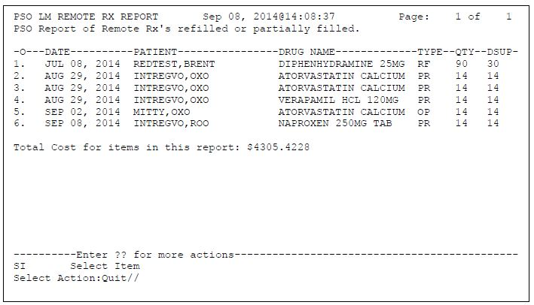

Figure : Remote Report Content Example

##### Our prescriptions, filled by other facilities

There are three search options available for the ‘Our prescriptions, filled by other facilities’ report. They are:

1. D: Date Range
2. P: Patient
3. S: Site

When selecting ‘D: Date Range’ the user is prompted to enter a start date and end date. The system defaults to 30 days prior to current system date as the start date and the current date as the end date.

When selecting ‘P: Patient’ the user is prompted to specify the patient’s name, social securing number, last four digits of the social security number, or first initial of last name with the last four digits of the social security number.

When selecting ‘S: Site’ the user is promoted to enter a site name, status, station number, official VA name, current location, coding system/id pair, NPI, name (changed from), or coding system.

The following table lists the values displayed on the report.

Table 11: Our prescriptions, filled by other facilities

| Report Column | Data Source *<Table Name. Fieldname>* |
| --- | --- |
| DATE FILLED |  |
| PATEINT |  |
| DRUG NAME |  |
| TYPE |  |
| QTY |  |
| DSUP |  |

The following image displays the remote report example.



Figure : Remote Report Content Example

##### All Remote activity

There are three search options available for the ‘All Remote activity’ report. They are:

1. D: Date Range
2. P: Patient
3. S: Site

When selecting ‘D: Date Range’ the user is prompted to enter a start date and end date. The system defaults to 30 days prior to current system date as the start date and the current date as the end date.

When selecting ‘P: Patient’ the user is prompted to specify the patient’s name, social securing number, last four digits of the social security number, or first initial of last name with the last four digits of the social security number.

When selecting ‘S: Site’ the user is promoted to enter a site name, status, station number, official VA name, current location, coding system/id pair, NPI, name (changed from), or coding system.

The following table lists the values displayed on the report.

Table 11: All Remote activity

| Report Column | Data Source *<Table Name. Fieldname>* |
| --- | --- |
| DATE FILLED |  |
| PATEINT |  |
| DRUG NAME |  |
| TYPE |  |
| QTY |  |
| DSUP |  |

The following image displays the remote report example.



Figure : Remote Report Content Example

#### Unmapped Data Element

Not applicable.

## Conceptual Infrastructure Design

The Conceptual Infrastructure Design should describe any unique technology that will be used, which are either part of this system, or will attach to this system.

. Because the system is at a preliminary design stage, it is expected that the information provided may need to be changed during later design stages or increments.

The Conceptual Infrastructure Design is a high-level overview of the infrastructure that will be used to support the application. Primary emphasis is on the environments that will be required and the locations at which they will be installed. The Conceptual Infrastructure Design becomes more detailed at later stages as more information is collected regarding the system, and the infrastructure requirements (i.e., capacity requirements) are better known.

### System Criticality and High Availability

Describe the approach that will be taken to meeting the system criticality and high availability requirements identified in Section 2.5.6, including the extent to which geographically distributed, high availability designs are planned. Describe the approach that is taken towards high availability as well as any workload distribution scheme that is planned to support the high availability implementation (e.g., restricting updates to a single node).

If the system is not mission critical and high availability is not required, then describe the approach that will be taken to provide the requisite level of availability and disaster recovery.

### Special Technology

If any special technology was identified in Section 2.5.9 as part of this system, describe the device and the type of location at which it will be installed. This information may be provided using Table 12.

Table 12: Special Technology Requirements

| Special Technology | Description | Notional Location | TRM Status |
| --- | --- | --- | --- |
| <Name> | <Business language description> | <At what type of location will this technology be deployed?> | <Is this technology in the TRM?  (Yes / No)> |

### Technology Locations

This section describes the various technology components that will be used. If known, provide the name of the datacenter at which the technology will be installed. If not, specify as Site A, Site B etc. Provide this information in Table 13.

Table 13: Technology Location Details

| Technology Component  Production 1 | Location | Usage |
| --- | --- | --- |
| Workstations |  |  |
| Special Hardware |  |  |
| Interface Processors |  |  |
| Legacy Mainframe |  |  |
| Legacy Application Server |  |  |
| Legacy Databases |  |  |
| Other |  |  |

| Technology Component  Production 2 | Location | Usage |
| --- | --- | --- |
| <copy from Prod 1 set, or enter new ones as appropriate> |  |  |

| Technology Component  Certification | Location | Usage |
| --- | --- | --- |
|  |  |  |

| Technology Component  Education | Location | Usage |
| --- | --- | --- |
|  |  |  |

| Technology Component  Test | Location | Usage |
| --- | --- | --- |
|  |  |  |

| Technology Component  Development | Location | Usage |
| --- | --- | --- |
|  |  |  |

### Conceptual Infrastructure Diagram

#### Location of Environments and External Interfaces

Create a diagram to show the environments that will be supported. As illustrated in Figure 7, the diagram should show the following:

* Local networks to which they will be attached (Production, Test, or Development)
* Locations at which they will be installed
* External connections (each external interface should be shown in terms of where it enters the network).

Figure : Sample Conceptual Networks and Environments

#### Conceptual Production String Diagram

Create a diagram to show the configuration of a single production string.

Additional components, such as the mainframe, other Web servers, or other major components should be included if they are expected to be required.

Figure : Conceptual Production String Diagram

# System Architecture

## Hardware Architecture

Describe the system hardware architecture and indicate whether the processing system is distributed or centralized. List and describe the hardware modules with diagrams showing the connectivity between the modules. If possible, identify the type, number, and location of servers, workstations, processors, backup systems, and output devices. Include information related to the capacity planning of the system.

## Software Architecture

### RESTful Web Services

In order to execute the messages from remote VistA systems, an interface is needed to expose calls to fill prescription orders. This can be accomplished by installing a RESTful web service on each VistA instance server. These services are used to read and write to the VistA Cache database as well as call VistA MUMPS methods.

### eMI ESB

The eMI ESB is responsible for message passing, routing and transformation. By utilizing several communication protocols and handing various message format, the eMI ESB is the backbone of the system. This system contains the following features described below. MLLP HL7 Endpoint

An MLLP Service will handle all incoming MLLP HL7 v2.x requests. The requests will be routed based on the message type and trigger event (MSH-10). The MLLP Service will route the following messages to the appropriate service:

Table : MLLP HL7 Endpoint Messages

| Message | Response | Description | Service Reference |
| --- | --- | --- | --- |
| QBP^Q13 | KTB^K13 | Query by parameter | **Error! Reference source not found.** |
| RDS^O13 | RRD^O14 | Pharmacy/Treatment Dispense Message | **Error! Reference source not found.** |

### HDR/CDS Endpoint

The eMI ESB will handle QBP-Q13 HL7 query requests to the HDR/CDS to retrieve a patient’s list of active prescriptions. The response will be in a JSON format which will be transformed into an HL7 v2.x RTB-K13 message with tabular data containing aggregated, active prescription information in the remote VistAs.

### Remote VistA Endpoint

This feature will route the HL7 refill requests to the appropriate VistA via it’s published interface. That interface will be the RESTful web service installed on the remote VistA machine.

### Sequence Diagrams

The next sub-sections show the sequence of event among key entities when the Use Cases are being executed.

#### View Order

The figure below shows two (2) VistAs. The remote VistA has refillable prescription order at some point in the past. The local VistA on the left is system currently in use by the end user. The local VistA is where the patient is physically located at the time the refill is requested. The provider will view all the active prescriptions. This will send a request to the HDR/CDS which has all active prescriptions in other VistA systems for the patient. When this result is combined with the current prescriptions, the user has the complete prescription orders for the patient.

| Use Case: View Orders |
| --- |
| The image displays the View Order Use Case. |

Figure : View Order Sequence diagram

#### Dispense Remote Order Sequence Diagram

Order displays the sequence of events to dispense a remote order. Like the sequence diagram above, an order was created for the patient at a remote VistA system. The user will view all active prescriptions for the patient and selects an active prescription from a remote VistA. Selecting that prescription and executing the fill order request, the system will send a message to the eMI ESB, which then routes the request to the correct remove VistA instance. This request will then decrement the prescription count, but will not affect the inventory of the remote facility. When the decrement is successful, that successful result is communicated back to the local VistA instance so that the prescription can be dispensed locally and a label is printed out.

| **Use Case: Dispense Local Order** |
| --- |
| The image displays the Dispense Remote Orders Use Case architectural layout. |

Figure : Dispense Remote Order Sequence diagram

### Design Rationale

The whole basis of this project is to allow standalone VistA system to send messages and affect each other’s state. This means message routing and transformation. By leveraging the VA’s overall goals to provide an enterprise system-to-system communication platform, the eMI ESB, this project can expose key functionality in VistA systems that will allow providers a higher level of care to patients. This also means leveraging system-wide information that has been collected into repositories like the HDR/CDS. Instead of querying each system individually, which can potentially be inefficient and fraught with lost communication, a single repository can be queried. The last piece of this system is the ESB to VistA communication. This is always the pain-point when dealing with any legacy system. The current implementation of the system uses Intrasystem’s Global API to execute VistA MUMPs commands. This API is required to be on the same machine as the VistA system.

### HL7 Protocol

The communication protocol used between components is HL7 v2.x. HL7 v2.x is a standard messaging protocol used to communicate among health information systems. Additionally, MyHealtheVet, a predecessor VA application, uses an HL7 v2 QBP-Q13 message to query prescriptions from VistA.

## Network Architecture

Describe communications within the system, such as local area networks (LANs) and buses. Include the communications architecture(s) being implemented, such as X.25 and token ring.

Provide a diagram depicting the communications path(s) between the system and subsystem modules.

## Service Oriented Architecture / ESS

This subsection of the SDD should put the product into perspective with other related products. This is achieved in the high level design.

* If the product is independent and totally self-contained, it should be so stated here.
* If the SDD defines a product that is a component of a larger system, as occurs frequently, then this subsection should relate the requirements of that larger system to functionality of the software and should identify interfaces between that system and the software. It is highly recommended that the SDD and other related artifacts of the larger system are included by reference, with links and not duplicate huge chunks of it here, which could potentially get out of sync. Integration projects depend on all parties understanding the same things about their relationships, and such information should be in one document and referenced by link as needed.

A block diagram showing the major components of the larger system, interconnections, and external interfaces can be helpful.

Services Provided: Those shared services that will be provided as part of this application (if the project is a combined solution and service development project). The Data Exchanges should then be included as part of whatever service is providing them. This may also be described as an attribute of the components listed in the high level application design when appropriate.

Service Required/Consumed: This would be the services this solution/application depends on. Again, data exchanges should be included as part of the service descriptions. This should also be adequately described in the conceptual and integration sections as appropriate.

Provide a diagram depicting the Enterprise Shared Services between the system and subsystem modules.

If the system currently being built is in-flight or in-transition, then depict the as-is, interim and target states of the system with diagrams, and identify the Enterprise Shared Services consumed or provided. This will be part of the conceptual solution design.

If the solution proposed is a duplication of an existing service, or a stand-alone silo solution, then appropriate justification needs to be provided.

## Enterprise Architecture

Describe the Enterprise Architecture of the system.

Show adherence to the VA Technical Reference Model (TRM)/ Standards Profile (SP). New system development and selection must adhere to approved standards and rules, unless it proves to be more cost-effective over the life of the application to deviate from the standards. The standards, strategies, and guidelines establish the fundamental technologies enabling the VA to meet many of its business and information system goals. By using these standards, the VA can promote interoperability, portability and adaptability within systems, promote quality assurance, place the VA in a position to utilize current technology, and provide a framework for IT application and infrastructure development. The current TRM/SP is located VA Enterprise Architecture (EA) v2.1 at <http://trm.oit.va.gov/>.

# Data Design

## DBMS Files

### Refill Multiple (#52.1) of the Prescription File (#52)

| Field Number | Field Name | Pointers | Cross References and Record Indices | Description |
| --- | --- | --- | --- | --- |
| 91 | Remote Fill Site | Institution File (#4) | “RFIL” | This is the site that performed the remote refill action. |
| 92 | Remote Pharmacist | N/A | N/A | This is the name of the remote pharmacist that performed the refill action. |
| 93 | Remote Pharmacist Phone | N/A | N/A | This is the phone number for the pharmacist that performed the refill action. |

### Partial Multiple (#52.2) of the Prescription File (#52)

| Field Number | Field Name | Pointers | Cross References and Record Indices | Description |
| --- | --- | --- | --- | --- |
| 91 | Remote Fill Site | Institution File (#4) | “RFIL” | This is the site that performed the remote partial fill action. |
| 92 | Remote Pharmacist | N/A | N/A | This is the name of the remote pharmacist that performed the partial fill action. |
| 93 | Remote Pharmacist Phone | N/A | N/A | This is the phone number for the pharmacist that performed the partial fill action. |

### Remote Prescription Log (#52.09)

| Field Number | Field Name | Pointers | Cross References and Record Indices | Description |
| --- | --- | --- | --- | --- |
| .01 | LOG DATE/TIME | N/A | 52.09^B | Date/Time of refill/partial fill transaction. |
| .02 | PATIENT | PATIENT (#2) | 52.09^C | This is the patient for which a refill or partial fill was executed remotely. |
| .03 | RX NUMBER | N/A | 52.9^D | This is the RX Number from the prescription file (#52). ** Should this be converted to a pointer??** |
| .04 | SITE NUMBER | INSTITUTION (#4) | 5209^E |  |
| .05 | REQUEST TYPE | N/A |  | RF – REFILL  PR – PARTIAL FILL  OR – OUTSIDE REFILL  OP – OUTSIDE PARTIAL FILL |
| .06 | OUTGOING REQUEST PHARMACIST | NEW PERSON (#200) | N/A | This is the pharmacist who initiated the refill or partial fill request to the remote facility. |
| .061 | REMOTE FILLING PHARMACIST | N/A | N/A | This is the pharmacist that requested a refill or partial fill from a remote facility. |
| .07 | QUANTITY | N/A | N/A | This is the quantity dispensed. |
| .08 | DAYS SUPPLY | N/A | N/A | This is the days supply for the medication. |
| .09 | REFILL/PARTIAL DATE | N/A | N/A | This is the date of the refill or partial fill request. This represents the date as it is logged in the .01 field of either the refill or partial sub files within the prescription file. |
| .1 | DISPENSED DATE | N/A | N/A | This is the Dispense date as it is held in the DISPENSED DATE within the REFILL or PARTIAL sub files of the PRESCRIPTION file. |
| 1 | REMOTE DRUG NAME | N/A | N/A | This is the name of the drug being dispensed for this request.** Note, we may want both the name and VA product id..*** |
| 1.1 | LOCAL (MATCHED) DRUG | DRUG (#50) | N/A | This is the drug that was used locally for the ‘remote’ refill or partial fill. |
| 1.2 | TOTAL REFILL/PARTIAL FILL COST | N/A | N/A | This is the total cost for the ‘remote’/filling facility. The cost is derived by using the cost of the drug at the time of the refill or partial fill. The cost is being retrieved from file 50, field 13. |
| 2 | MESSAGE DETAILS | N/A | N/A | Any message details related to the transaction. |
| 3 | LABEL DATA | N/A | N/A | Label data word processing field. |

## Non-DBMS Files

Not applicable.

## Data View

Not applicable.

# Detailed Design

This section describes the proposed design in detail. Provide the necessary information for the development team to integrate the hardware components and write the software code, so that the hardware and software components will provide a functional product. This is the detailed design, based upon the conceptual design (high level) that was described in the document up to this point.

Note: Every design item should map back to the Requirements Specification Document. These should be captured in the Requirement Traceability Matrix (RTM).

## Hardware Detailed Design

The information requested in this section may be provided by Engineering and/or the Developers. The information provided here is mainly for use by Engineering and Operations.

In this section, provide enough information for the developers to build and/or procure the system’s hardware. The level of detail requested should be treated as a general guideline and can be omitted if it needs to be filled in by Engineering and Operations.

Note: If this section becomes too lengthy, consider incorporating it as an appendix or reference it in a separate document. Add additional diagrams, if necessary, to describe each component and its functions.

Include the following information (as applicable):

* How much compute capacity? (MFLOPS, TPMs etc.)
* System Memory
* Local and Shared storage
* Network requirements (Bandwidth, Latency etc.)
* Public or Private cloud

## Software Detailed Design

This section provides conceptual and final detailed information associated with the design of the software being delivered. This should be an extension of the corresponding section from Section 3.1, but should contain additional detail as the project progresses.

### Conceptual Design

This section introduces the conceptual information that establishes the basis for how the software will be built.

#### Product Perspective

This subsection of the SDD should put the product into perspective with other related products. If the product is independent and completely self-contained, it should be stated here. If the SDD defines a product that is a component of a larger system, then this subsection should relate the requirements of that larger system to functionality of the software and should identify interfaces between that system and the software.

A block diagram showing the major components of the larger system, interconnections, and external interfaces can be helpful.

Sections of the Requirements Specification Document (RSD) can be referenced in the subsections, if applicable.

##### User Interfaces

This subsection should specify the logical characteristics of each interface between the software product and its users. This includes those configuration characteristics necessary to accomplish the software requirements (e.g., screens, roll and scroll, GUI interface).

Recommendation: Create a block diagram showing the user interfaces.

##### Hardware Interfaces

This subsection should specify the logical characteristics of each interface between the software product and the hardware components of the system. This includes configuration characteristics (for example, hardware platform or mainframe versus personal computer). It also covers matters such as what devices the system will support, how they will be supported, and protocols. Examples include scanners, pen driven devices, and radio frequency devices.

Recommendation: Create a block diagram showing the hardware interfaces.

##### Software Interfaces

This subsection should specify the use of other required software products (e.g., VA Kernel, VA FileMan, Windows NT); and interfaces with other applications or other systems such as commercial off-the-shelf (COTS) or national databases. Specify the application interfaces (e.g., the linkage between an accounts receivable system and a general ledger system and a COTS software package that will be interfaced using an existing interface). This section should provide the following information for each required software product:

* Name
* Version number
* Discussion of the purpose of the interfacing software as related to this software product
* Definition of the interface in terms of message content and format (e.g., Health Level Seven [HL7], electronic data interchange).

##### Communications Interfaces

This subsection should specify the various interfaces to communications such as local network protocols, e-mail, Transmission Control Protocol (TCP), modems.

Recommendation: Create a block diagram showing the communications interfaces.

##### Memory Constraints

This subsection should specify any applicable characteristics and limits on memory or partition size.

##### Special Operations

This subsection should specify the special operations required by the user such as backup, recovery, and archiving operations.

This section should also include any operations for external devices or COTS systems.

#### Product Features

This subsection should provide a summary of the major features of the software.

For example, an SDD for an accounting program might use this section to address customer account maintenance, customer statement, and invoice preparation without mentioning the vast amount of detail that each of those features requires.

Note: For clarity, remember these items when creating this section of the SDD:

* The features should be organized in a way that makes the list of features understandable to the customer or to anyone else reading the document for the first time.
* Textual or graphical methods can be used to show the different features and their relationships.
* Such a diagram is not intended to show a design of a product, but simply shows the logical relationships among variables.

#### User Characteristics

This subsection should describe the general characteristics of the intended users of the product, including experience and technical expertise. It should not be used to state specific requirements but rather should provide the reasons why certain specific requirements are specified in the RSD.

#### Dependencies and Constraints

This subsection should provide a description of any other items that will limit the developer’s options. The following list includes items that limit the developer’s options.

* Regulatory policies
* Hardware limitations (for example, signal timing requirements)
* Interfaces to other applications
* Parallel operation
* Audit functions
* Control functions
* Higher-order language requirements
* Reliability requirements
* Criticality of the application
* Safety and security considerations
* Usability (including 508 compliance)

This section of the SDD should contain all the software design to a level of detail sufficient to enable programmers to develop a system that satisfies the requirements defined in the RSD. It should be detailed so as to make it easy for technical staff to find the methods to complete the designed function.

These requirements should, at minimum, include the following items:

* An indication of the associated requirement(s) in the RSD which is being designed
* A description of the functionality being designed
* The design entities (and their attributes) affected
* The algorithm executed (where appropriate) to implement the functionality.

Because the Dependencies and Constraints section is often the largest and most important part of the SDD, the following principles apply:

* Specific design should be cross-referenced to earlier, related documents (e.g., the RSD).
* All design should be uniquely identifiable.
* Items in this section should be identified from a technical level rather than an end user level. (i.e., an option name should be identified rather than the menu text for that option).

### Specific Requirements

#### Database Repository

Not applicable.

#### System Features

The system features include functional requirements, sub-requirements, business rules, design constraints, etc. and are organized in a Requirements Specification Document (RSD). The OneVA Pharmacy Implementation projects RSD can be found in the VAs installation of the IBM Rational DOORS Next Generation Platform (RDNG) platform under the Pharmacy project in the OneVAPharm team area.

#### Design Element Tables

Not applicable.

##### Routines (Entry Points)

###### PSOORNE2

The ‘PSOORNE2’ routine has been modified to include the display of the remote prescriptions. This routine will display the details related to the remote Rx that has been selected.

Table 15 (Grouping): Routines

| Routines | Activities | | | |
| --- | --- | --- | --- | --- |
| **Routine Name** | PSOORNE2 | | | |
| **Enhancement Category** | New | Modify | Delete | No Change |
| **RTM** |  | | | |
| **Related Options** | PSO LM BACKDOOR ORDERS | | | |

| Related Routines | Routines “Called By” | Routines “Called” |
| --- | --- | --- |
|  | PSODISPS, PSOLMUTL, PSOMPHRC, PSOORCPY, PSOOREDT, PSOREF, PSORREF, PSORXEDT | PSOORNE6, PSOVER1, PSORRX1, PSOBUILD, PSOORUT1, PSODRG, PSOORNE5, PSONFI, PSOBPSUT, PSOHELP, PSOUTLA2, PSOORNE3, PSODAWUT, PSSDAWUT, PSOLMLST, PSOROS |

| Routines | Activities | | | | |
| --- | --- | --- | --- | --- | --- |
| **Data Dictionary (DD) References** | ^PSDRUG(  ^YSCL(603.01,  ^PS(50.606,  ^PS(50.7,  ^PS(52.5  ^PSRX(  ^DIC(4, | | | | |
| **Related Protocols** | N/A | | | | |
| **Related Integration Control Registrations (ICRs)** | 4708 – Call to DAWEXT^PSSDAWUT (Active/Controlled Subscription) | | | | |
| **Data Passing** | Input | Output Reference | Both | Global Reference | Local |
| **Input Attribute Name and Definition** | Name: N/A  Definition: | | | | |
| **Output Attribute Name and Definition** | Name: N/A  Definition: | | | | |

| Current Logic |
| --- |
| Cannot get current logic until we have all patches associated with this routine. |

| Modified Logic (Changes are in bold) |
| --- |
|  |

###### PSOORUT1

The ‘PSOORUT1’ routine has been modified to include the display of remote prescriptions within the [PSO LM BACKDOOR ORDER] prescription list. The prescriptions are sorted by facility and include the same display elements at eh local prescription. Each remote facility’s prescription list has a programmatically generated header that separates the prescriptions by status (Active, Suspended, Hold, etc.)

| Routines | Activities | | | |
| --- | --- | --- | --- | --- |
| **Routine Name** | PSOORUT1 | | | |
| **Enhancement Category** | New | Modify | Delete | No Change |
| **RTM** |  | | | |
| **Related Options** | PSO LM BACKDOOR ORDERS | | | |

| Related Routines | Routines “Called By” | Routines “Called” |
| --- | --- | --- |
|  | PSOCAN4, PSODISP3, PSOHLNEW, PSOLMUTL, PSONEW, PSOORFI2, PSOORFL, PSOORNE2, PSOORUTL, PSOREF, PSORENW4, PSORX1, PSOTPRX1, PSOVER | %DTC,DICN, DIK, DIQ, PSOBPSU1, PSOBPSUT, PSOHLSN1,PSOORUTL, PSOREJUT, PSOUTL, |

| Routines | Activities | | | | |
| --- | --- | --- | --- | --- | --- |
| **Data Dictionary (DD) References** | ^PS(52.41,  ^PSRX(  ^PS(52.5,  ^DIC(4, | | | | |
| **Related Protocols** |  | | | | |
| **Related Integration Control Registrations (ICRs)** | IA #221 – Access to ^PSDRUG  IA #2203 – Call to ^PSXOPUTL | | | | |
| **Data Passing** | Input | Output Reference | Both | Global Reference | Local |
| **Input Attribute Name and Definition** | Name: N/A  Definition: N/A | | | | |
| **Output Attribute Name and Definition** | Name: N/A  Definition: N/A | | | | |

| Current Logic |
| --- |
| Cannot get current logic until we have all patches associated with this routine. |

| Modified Logic (Changes are in bold) |
| --- |
|  |

###### PSOROS

The ‘PSOROS’ routine is the driving routine for selection of a ‘remote’ prescription within list manager. This routine controls the list template [PSO LM REMOTE ORDER SELECTION].

| Routines | Activities | | | |
| --- | --- | --- | --- | --- |
| **Routine Name** | PSOROS | | | |
| **Enhancement Category** | New | Modify | Delete | No Change |
| **RTM** |  | | | |
| **Related Options** |  | | | |

| Related Routines | Routines “Called By” | Routines “Called” |
| --- | --- | --- |
|  |  | VALM, PSONFI, XQORM1 |

| Routines | Activities | | | | |
| --- | --- | --- | --- | --- | --- |
| **Data Dictionary (DD) References** |  | | | | |
| **Related Protocols** | PSO LM REMOTE ORDER MENU  PSO LM REFILL REMOTE ORDER  PSO LM REMOTE PARTIAL | | | | |
| **Related Integration Control Registrations (ICRs)** | N/A | | | | |
| **Data Passing** | Input | Output Reference | Both | Global Reference | Local |
| **Input Attribute Name and Definition** | Name: N/A  Definition: N/A | | | | |
| **Output Attribute Name and Definition** | Name: N/A  Definition: N/A | | | | |

| Current Logic |
| --- |
| N/A |

|  |  |  |  |  |  |  |  |  |  |  |  |  |  |  |  |  |  |  |  |  |  |  |  |  |  |  |  |
| --- | --- | --- | --- | --- | --- | --- | --- | --- | --- | --- | --- | --- | --- | --- | --- | --- | --- | --- | --- | --- | --- | --- | --- | --- | --- | --- | --- |
| | Modified Logic (Changes are in bold) | | --- | |  |  PSORRD The ‘PSORRD’ routine is the routine that controls the PSO LM REMOTE REPORTS DETAILS list manager template. This routine is part of the Remote Prescription Report functionality.   | Routines | Activities | | | | | --- | --- | --- | --- | --- | | **Routine Name** | PSORRD | | | | | **Enhancement Category** | New | Modify | Delete | No Change | | **RTM** |  | | | | | **Related Options** |  | | | | |

| Related Routines | Routines “Called By” | Routines “Called” |
| --- | --- | --- |
|  |  | VALM, XQORM1 |

| Routines | Activities | | | | |
| --- | --- | --- | --- | --- | --- |
| **Data Dictionary (DD) References** | N/A | | | | |
| **Related Protocols** | N/A | | | | |
| **Related Integration Control Registrations (ICRs)** | N/A | | | | |
| **Data Passing** | Input | Output Reference | Both | Global Reference | Local |
| **Input Attribute Name and Definition** | Name:  Definition: | | | | |
| **Output Attribute Name and Definition** | Name:  Definition: | | | | |

| Current Logic |
| --- |
| N/A |

|  |  |  |  |  |  |  |
| --- | --- | --- | --- | --- | --- | --- |
| | Modified Logic (Changes are in bold) | | --- | |  |  PSORREF The ‘PSORREF’ routine is the main driving routine for the ‘receiving’ or ‘originating’ facility to process incoming refill requests. | | | | |
| Routines | Activities | | | |
| **Routine Name** | PSORREF | | | |
| **Enhancement Category** | New | Modify | Delete | No Change |
| **RTM** |  | | | |
| **Related Options** | PSO LM BACKDOOR ORDERS | | | |

| Related Routines | Routines “Called By” | Routines “Called” |
| --- | --- | --- |
|  |  | %DTC, %ZISH, DIE, DIQ, PSOBUILD, PSOCPTRI, PSOREJU1, PSORREF0, PSORREF1, PSORRX1, PSSLOCK, XLFDT, XUAF4 |

| Routines | Activities | | | | |
| --- | --- | --- | --- | --- | --- |
| **Data Dictionary (DD) References** | ^PSRX(  %ZIS(1,  ^PS(55, | | | | |
| **Related Protocols** | N/A | | | | |
| **Related Integration Control Registrations (ICRs)** | Need to see if we need any IA’s | | | | |
| **Data Passing** | Input | Output Reference | Both | Global Reference | Local |
| **Input Attribute Name and Definition** | Name: RXNUM  Definition: Prescription Number  Name: FDATE  Definition: Fill Date  Name: MW  Definition: Mail/Window  Name: RPHARM  Definition: Remote Pharmacists Name  Name: RPHONE  Definition: Remote Pharmacists Telephone Number  Name: RISTE  Definition: Remote site requesting the refill | | | | |
| **Output Attribute Name and Definition** | Name: RET  Definition: Return array “Rx # xxxxx refilled.”, or error message. | | | | |

| Current Logic |
| --- |
| N/A |

|  |  |  |  |  |  |  |
| --- | --- | --- | --- | --- | --- | --- |
| | Modified Logic (Changes are in bold) | | --- | |  |  PSORREF0 The ‘PSORREF0’ is a supporting routine to ‘PSORREF’. | | | | |
| Routines | Activities | | | |
| **Routine Name** | PSORREF0 | | | |
| **Enhancement Category** | New | Modify | Delete | No Change |
| **RTM** |  | | | |
| **Related Options** | PSO LM BACKDOOR ORDERS | | | |

| Related Routines | Routines “Called By” | Routines “Called” |
| --- | --- | --- |
|  | PSORREF1 | %DT, DIR, PSOPTPST, PSOR52, PSOREF1, PSOREF2, PSOUTIL, PSOUTLA, PSOUTLA1, VALM1 |

| Routines | Activities | | | | |
| --- | --- | --- | --- | --- | --- |
| **Data Dictionary (DD) References** | ^PSRX | | | | |
| **Related Protocols** |  | | | | |
| **Related Integration Control Registrations (ICRs)** | Will need to get included in IA 221 | | | | |
| **Data Passing** | Input | Output Reference | Both | Global Reference | Local |
| **Input Attribute Name and Definition** | Name:  Definition: | | | | |
| **Output Attribute Name and Definition** | Name: PSORMSG  Definition: Output message containing information about the refill request. | | | | |

| Current Logic |
| --- |
| N/A |

|  |  |  |  |  |  |  |
| --- | --- | --- | --- | --- | --- | --- |
| | Modified Logic (Changes are in bold) | | --- | |  |  PSORREF1 The ‘PSORREF1’ is a supporting routine for ‘PSORREF’. | | | | |
| Routines | Activities | | | |
| **Routine Name** | PSORREF1 | | | |
| **Enhancement Category** | New | Modify | Delete | No Change |
| **RTM** |  | | | |
| **Related Options** | PSO LM BACKDOOR ORDERS | | | |

| Related Routines | Routines “Called By” | Routines “Called” |
| --- | --- | --- |
|  | PSORREF | %DT |

| Routines | Activities | | | | |
| --- | --- | --- | --- | --- | --- |
| **Data Dictionary (DD) References** | ^PSRX | | | | |
| **Related Protocols** | N/A | | | | |
| **Related Integration Control Registrations (ICRs)** | N/A | | | | |
| **Data Passing** | Input | Output Reference | Both | Global Reference | Local |
| **Input Attribute Name and Definition** | N/A | | | | |
| **Output Attribute Name and Definition** | N/A | | | | |

| Current Logic |
| --- |
| N/A |

|  |  |  |  |  |  |  |
| --- | --- | --- | --- | --- | --- | --- |
| | Modified Logic (Changes are in bold) | | --- | |  |  PSORRP The ‘PSORRP’ routine assists in prompting for search criteria and display of the Remote Prescription Report. | | | | |
| Routines | Activities | | | |
| **Routine Name** | PSORRP | | | |
| **Enhancement Category** | New | Modify | Delete | No Change |
| **RTM** |  | | | |
| **Related Options** | PSO REMOTE RX REPORT | | | |

| Related Routines | Routines “Called By” | Routines “Called” |
| --- | --- | --- |
|  | N/A | %DT, DIC, DIQ, DIR, PSOROS, PSORRD, VALM, VALM1, VALM10, XLFDT, XQORM1 |

| Routines | Activities | | | | |
| --- | --- | --- | --- | --- | --- |
| **Data Dictionary (DD) References** | ^PSRXR(52.09, | | | | |
| **Related Protocols** |  | | | | |
| **Related Integration Control Registrations (ICRs)** | N/A | | | | |
| **Data Passing** | Input | Output Reference | Both | Global Reference | Local |
| **Input Attribute Name and Definition** | N/A | | | | |
| **Output Attribute Name and Definition** | N/A | | | | |

| Current Logic |
| --- |
| N/A |

|  |  |  |  |  |  |  |
| --- | --- | --- | --- | --- | --- | --- |
| | Modified Logic (Changes are in bold) | | --- | |  |  PSORRPA1 The ‘PSORRPA1’ is the main routine for processing an incoming partial fill request. | | | | |
| Routines | Activities | | | |
| **Routine Name** | PSORRPA1 | | | |
| **Enhancement Category** | New | Modify | Delete | No Change |
| **RTM** |  | | | |
| **Related Options** | PSO LM BACKDOOR ORDERS | | | |

| Related Routines | Routines “Called By” | Routines “Called” |
| --- | --- | --- |
|  | N/A | %ZISH, DIE, DIK, DIQ, PSOBPSUT, PSOCAN3, PSOCPTRI, PSOHLSN1, PSORRX1, PSORXL1, PSSLOCK, VADPT, XLFDT, XUAF4 |

| Routines | Activities | | | | |
| --- | --- | --- | --- | --- | --- |
| **Data Dictionary (DD) References** | ^PSRX(  ^PS(59,  ^PS(52.5,  ^%ZIS(1,  ^PS(55, | | | | |
| **Related Protocols** |  | | | | |
| **Related Integration Control Registrations (ICRs)** | IA 221?  IA 999?? | | | | |
| **Data Passing** | Input | Output Reference | Both | Global Reference | Local |
| **Input Attribute Name and Definition** | Name: RXNUM  Definition:  Name: PFDATE  Definition: Partial fill date  Name: MW  Definition: Mail/Window  Name: QTY  Definition: Quantity  Name: DSUPP  Definition: Days supply  Name: REMARKS  Definition: Remarks (if applicable)  Name: PHARM  Definition: Name of Filling pharmacist (remote)  Name: PHONE  Definition: Phone number of remote pharmacist  Name: SITE  Definition: Remote Site number | | | | |
| **Output Attribute Name and Definition** | Name: VALMSG  Definition: Response message for partial fill | | | | |

| Current Logic |
| --- |
| N/A |

|  |  |  |  |  |  |  |
| --- | --- | --- | --- | --- | --- | --- |
| | Modified Logic (Changes are in bold) | | --- | |  |  PSORRX1 The ‘PSORRX1’ routine builds the HL7 messages that are sent to the Pharmacy Remote Prescription Manager to retrieve, refill, and partial fill prescriptions from another facility. This routine uses the treating facility list to properly build the HL7 information to send to the ‘remote’ site(s). | | | | |
| Routines | Activities | | | |
| **Routine Name** | PSORRX1 | | | |
| **Enhancement Category** | New | Modify | Delete | No Change |
| **RTM** |  | | | |
| **Related Options** | PSO LM BACKDOOR ORDERS | | | |

| Related Routines | Routines “Called By” | Routines “Called” |
| --- | --- | --- |
|  | PSORX1 | %ZIS, DIC, DIE, DILFD, DIQ, DIR, HLFNC2, HLMA, PSODIR2, VAFCTFU2, VALM1, XLFDT, XUAF4 |

| Routines | Activities | | | | |
| --- | --- | --- | --- | --- | --- |
| **Data Dictionary (DD) References** |  | | | | |
| **Related Protocols** |  | | | | |
| **Related Integration Control Registrations (ICRs)** |  | | | | |
| **Data Passing** | Input | Output Reference | Both | Global Reference | Local |
| **Input Attribute Name and Definition** | Name: DFN  Definition: Patients local IEN | | | | |
| **Output Attribute Name and Definition** | HL7 MESSAGE IN HL7 QUEUE | | | | |

| Current Logic |
| --- |
| N/A |

|  |  |  |  |  |  |  |
| --- | --- | --- | --- | --- | --- | --- |
| | Modified Logic (Changes are in bold) | | --- | |  |  PSORWRAP The ‘PSORWRAP’ routine is the wrapper utility for the RESTful calls into VistA. | | | | |
| Routines | Activities | | | |
| **Routine Name** | PSORWRAP | | | |
| **Enhancement Category** | New | Modify | Delete | No Change |
| **RTM** |  | | | |
| **Related Options** | N/A | | | |

| Related Routines | Routines “Called By” | Routines “Called” |
| --- | --- | --- |
|  | N/A | PSORREF, PSORRPA1, XLFDT, XUP |

| Routines | Activities | | | | |
| --- | --- | --- | --- | --- | --- |
| **Data Dictionary (DD) References** | N/A | | | | |
| **Related Protocols** | N/A | | | | |
| **Related Integration Control Registrations (ICRs)** | N/A | | | | |
| **Data Passing** | Input | Output Reference | Both | Global Reference | Local |
| **Input Attribute Name and Definition** | Name: QBSESSID  Definition: Session ID  Name: QBDUZ  Definition: Users DUZ value | | | | |
| **Output Attribute Name and Definition** | Name: Status  Definition: returns session id and 1 if successful | | | | |

| Current Logic |
| --- |
| N/A |

|  |  |  |  |  |  |  |
| --- | --- | --- | --- | --- | --- | --- |
| | Modified Logic (Changes are in bold) | | --- | |  |  PSORX1 The ‘PSORX1’ routine has been modified to call ‘PSORRX1’ for retrieval of remote prescription data. | | | | |
| Routines | Activities | | | |
| **Routine Name** | PSORX1 | | | |
| **Enhancement Category** | New | Modify | Delete | No Change |
| **RTM** |  | | | |
| **Related Options** |  | | | |

| Related Routines | Routines “Called By” | Routines “Called” |
| --- | --- | --- |
|  |  | DTC, $ZISS, DGPFAPI, DIC, DICN, DIE, DIK, DIQ1, DIR, ORRDI1, PSOBAI, PSOBING, PSOBUILD, PSODDPR2, PSODEM, PSOHLUP, PSOLMAO, PSOLMUTL, PSOLSET, PSOORFI2, PSOORUT1, PSOORUT2, PSOPATLK, PSOPTPST, PSORMRX, PSORRX1, PSORXL, PSOSUPOE, PSUHL, VADPT, VALM1 |

| Routines | Activities | | | | |
| --- | --- | --- | --- | --- | --- |
| **Data Dictionary (DD) References** | ^PS(55,  ^DIC(31,  ^DPT(DO,.372,  ^XTMP(“ORRDI”  ^PSUHL  ^PSRX | | | | |
| **Related Protocols** | N/A | | | | |
| **Related Integration Control Registrations (ICRs)** | External reference ^PS(55 supported by DBIA 2228  External reference ^DIC(31 supported by DBIA 658  external reference ^DPT(D0,.372 supported by DBIA 1476  External reference DISPPRF^DGPFAPI supported by DBIA #4563  External reference ^ORRDI1 is supported by DBIA 4659  External reference ^XTMP("ORRDI" is supported by DBIA 4660  External reference ^PSUHL supported by DBIA 4803 | | | | |
| **Data Passing** | Input | Output Reference | Both | Global Reference | Local |
| **Input Attribute Name and Definition** | N/A | | | | |
| **Output Attribute Name and Definition** | N/A | | | | |

| Current Logic |
| --- |
| Cannot get current logic until we have all patches associated with this routine. |

|  |  |  |
| --- | --- | --- |
| | Modified Logic (Changes are in bold) | | --- | |  | |

##### Templates

###### PSO LM REMOTE ORDER SELECTION

The ‘PSO LM REMOTE ORDER SELECTION’ provides the logic needed to display a remote prescription within PSO LM BACKDOOR ORDERS.

| Templates | Description | | | |
| --- | --- | --- | --- | --- |
| **Template Name** | PSO LM REMOTE ORDER SELECTION | | | |
| **Enhancement Category** | New | Modify | Delete | No Change |
| **RSD** |  | | | |
| **Template Type** | Sort | Input | Print | Other |
| **Related Options** |  | | | |

| **Related Routines** | **Routines “Called By”** | **Routines “Called”** |
| --- | --- | --- |
|  | ^VALM |  |

| Routines | Description |
| --- | --- |
| **Data Dictionary (DD) References** | N/A |
| **Global References** |  |

PSO LM REMOTE REPORT DETAILS

The ‘PSO LM REMOTE REPORT DETAILS’ provides the logic that will display details about the remote report item.

| Templates | Description | | | |
| --- | --- | --- | --- | --- |
| **Template Name** | PSO LM REMOTE REPORT DETAILS | | | |
| **Enhancement Category** | New | Modify | Delete | No Change |
| **RSD** |  | | | |
| **Template Type** | Sort | Input | Print | Other |
| **Related Options** |  | | | |

| **Related Routines** | **Routines “Called By”** | **Routines “Called”** |
| --- | --- | --- |
|  |  |  |

| Routines | Description |
| --- | --- |
| **Data Dictionary (DD) References** | N/A |
| **Global References** |  |

PSO LM REMOTE RX REPORT

The ‘PSO LM REMOTE RS REPORT’ is the menu system for the selected items of the remote prescription report.

| Templates | Description | | | |
| --- | --- | --- | --- | --- |
| **Template Name** | PSO LM REMOTE RX REPORT | | | |
| **Enhancement Category** | New | Modify | Delete | No Change |
| **RSD** |  | | | |
| **Template Type** | Sort | Input | Print | Other |
| **Related Options** |  | | | |

| **Related Routines** | **Routines “Called By”** | **Routines “Called”** |
| --- | --- | --- |
|  |  |  |

| Routines | Description |
| --- | --- |
| **Data Dictionary (DD) References** | N/A |
| **Global References** |  |

##### Bulletins

If the project develops or affects bulletins, then complete this section; if not then state that the section is not applicable and delete the tables and content of the section. Complete the table for each bulletin affected by the functionality being designed. A short description of what change will be made to the bulletins should be included in this section.

Note: If preferred, copy and paste this section directly from VA FileMan DDs instead of using the tables.

Table 18: Bulletins (Instructions)

|  |  |
| --- | --- |
| Bulletins | Instructions |
| **Bulletin Name** | List the specific bulletin affected by the functionality being designed. |
| **Enhancement Category** | Check the appropriate box: New, Modify, Delete, or No Change. |
| **RTM** | List the RSD item number within the SDD (i.e., If the RSD has a requirement of 3.3.1, add Support for a new API, then in this column list RSD Requirement 3.3.1). |
| **Related Options** | List options that directly send the bulletin. |
| **Related Routines** | List routines that directly send the bulletin. |
| **Mail Subject** | List the subject of the mail message, i.e., which bulletin this affects. |
| **Mail Group** | List the mail group (recipients) of the mail message. |
| **Parameters** | List necessary parameters. |
| **Data Dictionary (DD) References** | List files/fields that reference the bulletin(s) through input transforms, cross reference logic, etc. should be listed under Data Dictionary (DD) References. |

Table 19: Bulletins

| Bulletins | Description | | | |
| --- | --- | --- | --- | --- |
| **Bulletin Name** |  | | | |
| **Enhancement Category** | New | Modify | Delete | No Change |
| **RTM** |  | | | |

| Related Routines | Routines “Called By” | Routines “Called” |
| --- | --- | --- |
|  |  |  |

| Routines | Description |
| --- | --- |
| **Mail Subject** |  |
| **Mail Group** |  |
| **Parameters** |  |
| **Data Dictionary (DD) References** |  |

##### Data Entries Affected by the Design

Not applicable.

##### Unique Record(s)

Not applicable.

##### File or Global Size Changes

###### Global

The Pharmacy Remote Prescription Manager uses the following globals:

^PSRX

^PSRXR

The ^PSRX global holds the prescription data. The ^PSRXR global holds a comprehensive list of information regarding remote refill and partial fill activity.

Table : Global Placement and Protection

|  |  |  |  |  |
| --- | --- | --- | --- | --- |
| Global | Type | Placement | Journal | Protection |
| ^PSRX | Dynamic | No changes should be made to the current placement or settings related to this global | No change | No change |
| ^PSRXR | Static | Place this global in a volume set that can accommodate the following yearly growth rate: 2,000 bytes * visits per year | Yes | RWP or D |

###### Files

Table : Files

| File # | File Name | Root Global | Global Protection |
| --- | --- | --- | --- |
| 52 | PRESCRIPTION | ^PSRX | No change |
| 52.09 | REMOTE PRESCRIPTION LOG | ^PSRXR(52.09 | @ |

Prescription (#52) File

The overall prescription file definition remains unchanged, however there are a few modifications that track information related to a remote refill or partial fill. Those changes are listed in the following tables and are isolated to the sub-files for refill and partial fill.

REFILL Sub File (#52.1)

Table : REFILL Sub file (#52.1)

| Field Number | Field Name | Pointers | Cross References and Record Indices | Description |
| --- | --- | --- | --- | --- |
| 91 | REMOTE FILL SITE | Pointer to the Institution file (#4) | 52^RFIL | Pointer field: Points to the Institution from which the refill or partial fill request was generated. |
| 92 | REMOTE PHARMACIST | N/A | N/A | Free-text field: This free text field holds the name of the remote requesting pharmacist. This is the pharmacist that made the remote refill or partial fill request. |
| 93 | REMOTE PHARMACIST PHONE | N/A | N/A | Free-text field: This is the contact number for the remote (requesting) pharmacist. This is the pharmacist that initiated the remote refill or partial fill request. |

PARTIAL FILL Sub file (#52.2)

Table : PARTIAL FILL sub file (#52.2)

| Field Number | Field Name | Pointers | Cross References and Record Indices | Description |
| --- | --- | --- | --- | --- |
| 91 | REMOTE FILL SITE | Pointer to the Institution file (#4) | 52^PFIL | Pointer field: Points to the Institution from which the refill or partial fill request was generated. |
| 92 | REMOTE PHARMACIST | N/A | N/A | Free-text field: This free text field holds the name of the remote requesting pharmacist. This is the pharmacist that made the remote refill or partial fill request. |
| 93 | REMOTE PHARMACIST PHONE | N/A | N/A | Free-text field: This is the contact number for the remote (requesting) pharmacist. This is the pharmacist that initiated the remote refill or partial fill request. |

Remote Prescription Log (#52.09) File

Table : Remote Prescription Log (#52.09

| Field Number | Field Name | Pointers | Cross References and Record Indices | Description |
| --- | --- | --- | --- | --- |
| .01 | LOG DATE/TIME | N/A | 52.09^B | Date/Time (required): This is the date/time of the refill or partial fill activity. |
| .02 | PATIENT | Pointer to the PATIENT file (#2) | 52.09^C | Pointer field (required): This is the pointer to the patient file, which identifies what patient the refill or partial refill request is for. |
| .03 | RX NUMBER | N/A | 52.09^D | Free Text (required): This is the prescription number as it exists at the ‘originating’ facility. |
| .04 | SITE NUMBER | Pointer to the INSTITUTION file (#4) | 52.09^E | Pointer field (required): This is the pointer that identifies which facility was the ‘originating’ facility for this refill or partial fill request. |
| .05 | REQUEST TYPE | N/A |  | Set of codes: RF for REFILL (outgoing)  PR for PARTIAL FILL (outgoing)  OR for OUTSIDE REFILL (incoming)  OP for OUTSIDE PARTIAL FILL (incoming) |
| .06 | OUTGOING REQUEST PHARMACIST | Pointer to the NEW PERSON file (#200) |  | Pointer field (required): This is the pointer to the person who initiated a refill or partial fill request to a remote facility. |
| .07 | REMOTE FILLING PHARMACIST | N/A | N/A | Free Text: This is the textual name of the pharmacist who is requesting a refill or partial fill from a remote facility. This field is used to log ‘incoming’ refill and partial fill pharmacist data. |
| .07 | QUANTITY | N/A | N/A | Numeric: This is the quantity associated with the remote refill or partial fill. |
| .08 | DAYS SUPPLY | N/A | N/A | Numeric: This is the days supply associated with the remote fill or partial fill request. |
| .09 | REFILL/PARTIAL DATE | N/A | N/A | Date: This is the date for the refill or partial fill request. This represents the date as it is logged in the .01 field of either the REFILL (#52.1) or PARTAIL DATE (#52.2) sub file within the PRESCRIPTION file (#52). |
| .1 | DISPENSED DATE | N/A | N/A | Date: This is the date that the remote prescription request was dispensed. |
| 1 | REMOTE DRUG NAME | N/A | N/A | Free Text: This is the textual value for the remote drug. |
| 1.1 | LOCAL (MATCHED) DRUG | Pointer to the DRUG file (#50) | N/A | Pointer to the DRUG file (#50). This holds the locally identified drug that is equivalent to the drug name that is received from the remote (originating) facility. |
| 1.2 | TOTAL REFILL/PARTIAL COST | N/A | N/A | Numeric: This field is used to store the total cost for the refill or partial fill request. This value is based on the current cost of the drug, multiplied by the quantity. |
| 2 | MESSAGE DETAILS | N/A | N/A | Word-processing: This is where any additional message details are stored. |
| 3 | LABEL DATA | N/A | N/A | Word-processing: Once label data has been received from the originating facility, it is stored here for future reference and reprint. |

##### Mail Groups

Not applicable.

##### Security Keys

Not applicable.

##### Options

###### Pharmacy Remote Prescription Manager Options

| Name | Type | Description |
| --- | --- | --- |
| PSO LM BACKDOOR ORDERS | Menu |  |
| PSO RX | Menu | The overarching menu in which PSO REMOTE RX REPORT is contained. |
| PSO REMOTE RX REPORT | Run Routine | This option provides details about remote refill and partial fill request, as well as incoming refill and partial fill requests. |

PSO LM BACKDOOR ORDERS Option

| Options | Activities | | | | | | | | | | |
| --- | --- | --- | --- | --- | --- | --- | --- | --- | --- | --- | --- |
| **Option Name** | PSO LM BACKDOOR ORDERS | | | | | | | | | | |
| **Enhancement Category** | New | Modify | | | | Delete | | | No Change | | |
| **Associated Menu Options that will invoke this reference** |  | | | | | | | | | | |
| **Data Passing** | Input | | Output | | Both | | | Global Reference | | | Local Reference |
| **Menu Text Description** |  | | | | | | | | | | |
| **Option Type** | Edit | | | Print | | | Menu | | | Inquire | |
| Action | | | Run Routine | | | Other | | |  | |
| **Associated Routine** |  | | | | | | | | | | |
| **Option Definition** |  | | | | | | | | | | |

| Current Entry Action Logic |
| --- |
|  |

| Modified Entry Action Logic (Changes are in bold) |
| --- |
|  |

| Current Exit Action Logic |
| --- |
|  |

| Modified Exit Action Logic (Changes are in bold) | | | | | | | | | | | |
| --- | --- | --- | --- | --- | --- | --- | --- | --- | --- | --- | --- |
| PSO RX Options | | | | | | | | | | | |
| Options | Activities | | | | | | | | | | |
| **Option Name** | PSO RX | | | | | | | | | | |
| **Enhancement Category** | New | Modify | | | | Delete | | | No Change | | |
| **Associated Menu Options that will invoke this reference** |  | | | | | | | | | | |
| **Data Passing** | Input | | Output | | Both | | | Global Reference | | | Local Reference |
| **Menu Text Description** | Rx (Prescriptions) | | | | | | | | | | |
| **Option Type** | Edit | | | Print | | | Menu | | | Inquire | |
| Action | | | Run Routine | | | Other | | |  | |
| **Associated Routine** | PSOLSET, PSOORFIN | | | | | | | | | | |
| **Option Definition** |  | | | | | | | | | | |

| Current Entry Action Logic |
| --- |
| D ^PSOLSET:'$D(PSOPAR) D CHK^PSOORFIN |

| Modified Entry Action Logic (Changes are in bold) |
| --- |
| N/A |

| Current Exit Action Logic |
| --- |
| N/A |

| Modified Exit Action Logic (Changes are in bold) |
| --- |
| N/A |

PSO REMOTE RX REPORT Option

| Options | Activities | | | | | | | | | | |
| --- | --- | --- | --- | --- | --- | --- | --- | --- | --- | --- | --- |
| **Option Name** | PSO REMOTE RX REPORT | | | | | | | | | | |
| **Enhancement Category** | New | Modify | | | | Delete | | | No Change | | |
| **Associated Menu Options that will invoke this reference** | PSO RX | | | | | | | | | | |
| **Data Passing** | Input | | Output | | Both | | | Global Reference | | | Local Reference |
| **Menu Text Description** | Remote Prescription Report | | | | | | | | | | |
| **Option Type** | Edit | | | Print | | | Menu | | | Inquire | |
| Action | | | Run Routine | | | Other | | |  | |
| **Associated Routine** | PSOLSET, PSOORFIN | | | | | | | | | | |
| **Option Definition** | Remote RX Prescription report display. | | | | | | | | | | |

| Current Entry Action Logic |
| --- |
| N/A |

| Modified Entry Action Logic (Changes are in bold) |
| --- |
| D ^PSORRP |

| Current Exit Action Logic |
| --- |
| N/A |

| Modified Exit Action Logic (Changes are in bold) |
| --- |
| N/A |

##### Protocols

PSO LM REFILL REMOTE ORDER Protocol

| Protocols | Activities |
| --- | --- |
| **Protocol Name** | PSO LM REFILL REMOTE ORDER |
| **Enhancement Category** | New  Modify  Delete  No Change |
| **Associated Protocols** | PSO LM REMOTE ORDER MENU |
| **Data Passing** | Input  Output  Both  Global Reference  Local Reference |
| **Item Text Description** |  |
| **Protocol Type** | Action  Menu  Protocol  Protocol Menu  Limited Protocol  Extended Action  Dialog  Other |
| **Associated Routine** | PSORRX1 |

| Current Entry Action Logic |
| --- |
| N/A |

| Modified Entry Action Logic (Changes are in bold) |
| --- |
| D REFREQ^PSORRX1 |

| Current Exit Action Logic |
| --- |
| N/A |

| Modified Exit Action Logic (Changes are in bold) |
| --- |
| N/A |

PSO LM REMOTE ORDER MENU Protocol

| Protocols | Activities |
| --- | --- |
| **Protocol Name** | PSO LM REMOTE ORDER MENU |
| **Enhancement Category** | New  Modify  Delete  No Change |
| **Associated Protocols** | PSO LM REFILL REMOTE ORDER  PSO LM REMOTE PARTIAL |
| **Data Passing** | Input  Output  Both  Global Reference  Local Reference |
| **Item Text Description** | Remote Order Menu |
| **Protocol Type** | Action  Menu  Protocol  Protocol Menu  Limited Protocol  Extended Action  Dialog  Other |
| **Associated Routine** | N/A |

| Current Entry Action Logic |
| --- |
| N/A |

| Modified Entry Action Logic (Changes are in bold) |
| --- |
| N/A |

| Current Exit Action Logic |
| --- |
| N/A |

| Modified Exit Action Logic (Changes are in bold) |
| --- |
| N/A |

PSO LM REMOTE PARTIAL Protocol

| Protocols | Activities |
| --- | --- |
| **Protocol Name** | PSO LM REMOTE PARTIAL |
| **Enhancement Category** | New  Modify  Delete  No Change |
| **Associated Protocols** | PSO LM REMOTE ORDER MENU |
| **Data Passing** | Input  Output  Both  Global Reference  Local Reference |
| **Item Text Description** | Partial |
| **Protocol Type** | Action  Menu  Protocol  Protocol Menu  Limited Protocol  Extended Action  Dialog  Other |
| **Associated Routine** | PSORRX1 |

| Current Entry Action Logic |
| --- |
| N/A |

| Modified Entry Action Logic (Changes are in bold) |
| --- |
| D PARTIAL^PSORRX1 |

| Current Exit Action Logic |
| --- |
| N/A |

| Modified Exit Action Logic (Changes are in bold) |
| --- |
| N/A |

PSO LM REMOTE RX REPORT MENU Protocol

| Protocols | Activities |
| --- | --- |
| **Protocol Name** | PSO LM REMOTE RX REPORT MENU |
| **Enhancement Category** | New  Modify  Delete  No Change |
| **Associated Protocols** | PSO LM SELECT REPORT ITEM |
| **Data Passing** | Input  Output  Both  Global Reference  Local Reference |
| **Item Text Description** | Remote Rx Selection** |
| **Protocol Type** | Action  Menu  Protocol  Protocol Menu  Limited Protocol  Extended Action  Dialog  Other |
| **Associated Routine** | N/A |

| Current Entry Action Logic |
| --- |
| N/A |

| Modified Entry Action Logic (Changes are in bold) |
| --- |
| N/A |

| Current Exit Action Logic |
| --- |
| N/A |

| Modified Exit Action Logic (Changes are in bold) |
| --- |
| N/A |

PSO LM SELECT REPORT ITEM Protocol

| Protocols | Activities |
| --- | --- |
| **Protocol Name** | PSO LM SELECT REPORT ITEM |
| **Enhancement Category** | New  Modify  Delete  No Change |
| **Associated Protocols** | PSO LM REMOTE RX REPORT MENU |
| **Data Passing** | Input  Output  Both  Global Reference  Local Reference |
| **Item Text Description** |  |
| **Protocol Type** | Action  Menu  Protocol  Protocol Menu  Limited Protocol  Extended Action  Dialog  Other |
| **Associated Routine** | PSORRP |

| Current Entry Action Logic |
| --- |
| N/A |

| Modified Entry Action Logic (Changes are in bold) |
| --- |
| D SEL^PSORRP |

| Current Exit Action Logic |
| --- |
| N/A |

| Modified Exit Action Logic (Changes are in bold) |
| --- |
| N/A |

ZJTH PHARM QBP Q13 ESUBS** Protocol

| Protocols | Activities |
| --- | --- |
| **Protocol Name** | ZJTH PHARM QBP-Q13 ESUBS** |
| **Enhancement Category** | New  Modify  Delete  No Change |
| **Associated Protocols** |  |
| **Data Passing** | Input  Output  Both  Global Reference  Local Reference |
| **Item Text Description** |  |
| **Protocol Type** | Action  Menu  Protocol  Protocol Menu  Limited Protocol  Extended Action  Dialog  Other |
| **Associated Routine** |  |

| Current Entry Action Logic |
| --- |
|  |

| Modified Entry Action Logic (Changes are in bold) |
| --- |
|  |

| Current Exit Action Logic |
| --- |
|  |

| Modified Exit Action Logic (Changes are in bold) |
| --- |
|  |

ZJTH PHARM QBP Q13 EVENT** Protocol

| Protocols | Activities |
| --- | --- |
| **Protocol Name** | ZJTH PHARM QBP-Q13 EVENT** |
| **Enhancement Category** | New  Modify  Delete  No Change |
| **Associated Protocols** |  |
| **Data Passing** | Input  Output  Both  Global Reference  Local Reference |
| **Item Text Description** |  |
| **Protocol Type** | Action  Menu  Protocol  Protocol Menu  Limited Protocol  Extended Action  Dialog  Other |
| **Associated Routine** |  |

| Current Entry Action Logic |
| --- |
|  |

| Modified Entry Action Logic (Changes are in bold) |
| --- |
|  |

| Current Exit Action Logic |
| --- |
|  |

| Modified Exit Action Logic (Changes are in bold) |
| --- |
|  |

ZJTH PHARM RDS-013 ESUBS Protocol

| Protocols | Activities |
| --- | --- |
| **Protocol Name** | ZJTH PHARM RDS-O13 ESUBS |
| **Enhancement Category** | New  Modify  Delete  No Change |
| **Associated Protocols** |  |
| **Data Passing** | Input  Output  Both  Global Reference  Local Reference |
| **Item Text Description** |  |
| **Protocol Type** | Action  Menu  Protocol  Protocol Menu  Limited Protocol  Extended Action  Dialog  Other |
| **Associated Routine** |  |

| Current Entry Action Logic |
| --- |

| Modified Entry Action Logic (Changes are in bold) |
| --- |

| Current Exit Action Logic |
| --- |

| Modified Exit Action Logic (Changes are in bold) |
| --- |

ZJTH PHARM RDS-013 EVENT Protocol

| Protocols | Activities |
| --- | --- |
| **Protocol Name** | ZJTH PHARM RDS-O13 EVENT |
| **Enhancement Category** | New  Modify  Delete  No Change |
| **Associated Protocols** |  |
| **Data Passing** | Input  Output  Both  Global Reference  Local Reference |
| **Item Text Description** |  |
| **Protocol Type** | Action  Menu  Protocol  Protocol Menu  Limited Protocol  Extended Action  Dialog  Other |
| **Associated Routine** |  |

| Current Entry Action Logic |
| --- |

| Modified Entry Action Logic (Changes are in bold) |
| --- |

| Current Exit Action Logic |
| --- |

| Modified Exit Action Logic (Changes are in bold) |
| --- |

##### Remote Procedure Call (RPC)

N/A** Will this change in the event we modify the architecture to move away from the HL7 Logical links??

Table 31: RPCs (Instructions)

| RPCs | Instructions |
| --- | --- |
| **Name** | List the specific name of the RPC affected. |
| **TAG^RTN** | List the tag (label) and routine. |
| **Input Parameters** | This field is used to identify an input parameter for the API. |
| **Results Array** | This field tells the RPC Broker how to process the resulting data from the call. |
| **Description** | Provide a brief description of the RPC affected. |

Table 32: RPCs

| RPCs | Activities | | |
| --- | --- | --- | --- |
| **Name** |  | | |
| **TAG^RTN** |  | | |
| **Input Parameters** |  | | |
| **Results Array** | Single Value | Array | Word Processing |
| Global Array | Global Instance |  |
| **Description** |  | | |

##### Constants Defined in Interface

Provide the name and description.

Table 33: Constants Defined in Interface

| Name | Description |
| --- | --- |
|  |  |

##### Variables Defined in Interface

Provide the name, type, and description.

Table 34: Variables Defined in Interface

| Name | Type | Description |
| --- | --- | --- |
|  |  |  |

##### Types Defined in Interface

Provide the name, type, and description.

Table 35: Types Defined in Interface

| Name | Type | Description |
| --- | --- | --- |
|  |  |  |

##### GUI

List the GUI affected by the functionality being designed and include a short description of the changes made to the affected GUI. The headers in the following tables have names for the information outlined. There are a number of items in this section that would generally be global information and visible to all other aspects.

Table 36: GUI

| Unit Name | Description |
| --- | --- |
|  |  |

##### GUI Classes

Table 37: GUI Classes (Instructions)

| GUI Classes | Instructions |
| --- | --- |
| **Class Name** | List the name of the class affected. The headers in the following tables have names for the information outlined. Note that only the new properties and methods for a class are listed below. All ancestor properties and methods are still available and unchanged. |
| **Derived From Class** | List the class that this is derived from, its parent and any interfaces listed as part of this class. |
| **Purpose** | Describe the functionality that users can access from this class and related form, if any. |

Table 38: GUI Classes

| GUI Classes | Instructions |
| --- | --- |
| **Class Name** |  |
| **Derived From Class** |  |
| **Purpose** |  |

##### Current Form

Provide a screen capture or graphical representation of the current layout.

##### Modified Form

Provide a screen capture or graphical representation of the layout that the design will implement.

##### Components on Form

Table 39: Components on Form

| Name | Type | Description |
| --- | --- | --- |
|  |  |  |

##### Events

Table 40: Events

| Name | Type | Description |
| --- | --- | --- |
|  |  |  |

##### Methods

Table 41: Methods

| Method Name | Procedure/Function | Description |
| --- | --- | --- |
|  |  |  |

##### Special References

Include references that are not listed elsewhere.

| Special Reference Name | Type | Description |
| --- | --- | --- |
|  |  |  |

##### Class Events

Table 42: Class Events

| Name | Type | Description |
| --- | --- | --- |
|  |  |  |

##### Class Methods

Table 43: Class Methods

| Name | Procedure/Function | Description |
| --- | --- | --- |
|  |  |  |

##### Class Properties

Table 44: Class Properties

| Class Properties Name | Type | Visibility | Description |
| --- | --- | --- | --- |
|  |  |  |  |

##### Uses Clause

Use this section to provide a uses clause that lists the other units (code or form units) that this unit will use. This may be documented in the form of a Unified Modeling Language (UML) drawing.

##### Forms

This section lists the forms that will be affected or created by the functionality being designed. A short description of the change that will be made to the forms should be included.

Table 45: Forms (Instructions)

| Forms | Instructions |
| --- | --- |
| **Form Name** | List the name of the form affected by the functionality being designed. |
| **Enhancement Category** | Check the appropriate box: New, Modify, Delete, or No Change. |
| **Form Functionality** | Describe the form’s functionality and refer to the usage of the form. An example of such a description is “This form is used to enter patient demographic data.” |
| **Current Form Layout** | Define the current form layout that the design will modify. If this is a new form, enter “N/A”. |
| **Modified Form Layout (Changes are in bold)** | Define the form layout that the design will implement. |

Table 46: Forms

| Forms | Description | | | |
| --- | --- | --- | --- | --- |
| **Form Name** |  | | | |
| **Enhancement Category** | New | Modify | Delete | No Change |
| **Form Functionality** |  | | | |

| Current Form Layout |
| --- |
|  |

| Modified Form Layout (Changes are in bold) |
| --- |
|  |

##### Functions

The functions affected by the capabilities being designed should be listed in this section. A short description of what change will be made to the functions and/or new functions should be included.

Table 47: Forms (Instructions)

| Functions | Instructions |
| --- | --- |
| **Function Name** | List the specific function affected by the capability being designed. |
| **Short Description** | List a short description of the change that will be made to the functions and/or new functions. |
| **Enhancement Category** | Check the appropriate box: New, Modify, Delete, or No Change. |
| **Related Options** | List the options that directly call or are called by the function. |
| **Related Routines** | List the routines that directly call or are called by the function. |
| **Data Dictionary (DD) References** | List the files that reference the function through input transforms, cross reference logic, etc. |
| **Related Protocols** | List the protocols that reference or are referenced by the function. |
| **Related Integration Control Registrations (ICRs)** | List proposed new ICRs and subscribed ICRs. Also, list any obscure Supported ICRs. |
| **Data Passing** | Check the appropriate box. An event that would trigger the new/changed function should be included in this section. An example of such a description would be a note that the new/changed function will be invoked as part of a function call or it would be invoked through system protocols, HL7 Logical Links, etc. This section refers specifically to the change implemented with the design. |
| **Input Attribute Name and Definition** | List the input attributes passed into the new or changed function logic. Each attribute should be defined. |
| **Output Attribute Name and Definition** | List the output attributes returned from the new or changed function logic. Each attribute should be defined. |
| **Current Logic** | Define the current logic in the function that the design will modify. If this is new code, enter “N/A”. |
| **Modified Logic (Changes are in bold)** | Define the logic in the function that the design will implement. |

Table 48: Forms

| Function Name | Activities | | | |
| --- | --- | --- | --- | --- |
| **Short Description** |  | | | |
| **Enhancement Category** | New | Modify | Delete | No Change |
| **Related Options** |  | | | |

| Related Routines | Routines “Called By” | Routines “Called” |
| --- | --- | --- |
|  |  |  |

| Function Name | Activities | | | | |
| --- | --- | --- | --- | --- | --- |
| **Data Dictionary (DD) References** |  | | | | |
| **Related Protocols** |  | | | | |
| **Related Integration Control Registrations (ICRs)** |  | | | | |
| **Data Passing** | Input | Output | Both | Global Reference | Local Reference |
| **Input Attribute Name and Definition** | Name: | | | | |
| Definition: | | | | |
| **Output Attribute Name and Definition** | Name: | | | | |
| Definition: | | | | |

| Current Logic |
| --- |
|  |

| Modified Logic (Changes are in bold) |
| --- |
|  |

##### Dialog

Not applicable.

##### Help Frame

A short description of what change will be made to the Help Frame text and/or new text should be included in this section. Help frames may be associated with options or with data dictionary fields to provide on-line instruction.

Table 51: Help Frame (Instructions)

| Help Frame | Instructions |
| --- | --- |
| **Help Frame Text** | List the text affected or needed by the changes being designed. |
| **Enhancement Category** | Check the appropriate box: New, Modify, Delete, or No Change. |
| **Help Frame Text Calling Mechanism** | Provide a short description of the mechanism used to call the Help Frame text in this section. An example of a mechanism would be the name of the routine or an explanation of how the Help Frame is called. An example of a calling mechanism would be the Standard VA FileMan API and the keystroke(s) that would trigger the output of the text. |
| **Current Help Frame Text** | List the current Help Frame Text that the design will modify. If new text enter N/A. |
| **Modified Help Frame Text (Changes are in bold)** | List the Help Frame Text that the design will modify. |

Table 52: Help Frame

| Help Frame | Description | | | |
| --- | --- | --- | --- | --- |
| **Help Frame Text** |  | | | |
| **Enhancement Category** | New | Modify | Delete | No Change |
| **Help Frame Text Calling Mechanism** |  | | | |

| Current Help Frame Text |
| --- |
|  |

| Modified Help Frame Text (Changes are in bold) |
| --- |
|  |

##### HL7 Application Parameter

The MUMPS Patient Prescription Processing [PSO LM BACKDOOR ORDERS] menu option will be modified. The modifications include making a HL7 requests to the Prescription Manager Server for viewing and filling remote prescriptions.

### HL7 Protocols

An HL7 protocol event and subscriber will be configured in VistA to handle sending HL7 requests to the Prescription Manager Server. Protocols will be set up to handle all messages. The following is an example configuration of a protocol to handle QBP-Q13 Events:

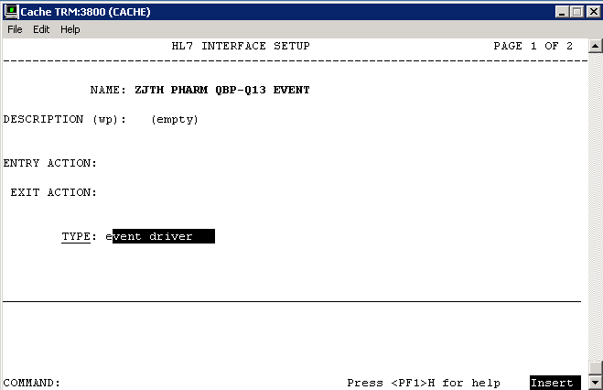

Figure : Example of Configuration of a Protocol to handle QBP-Q13 Events

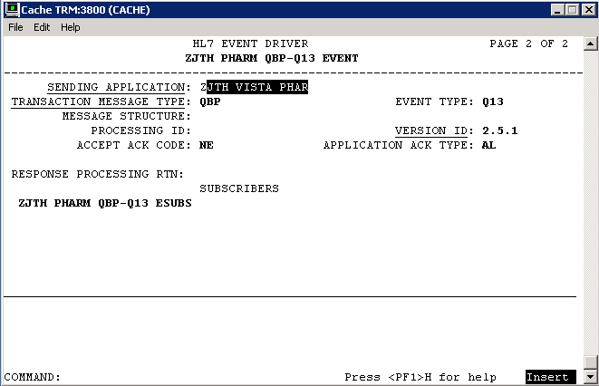

Figure : Example of Configuration of a Protocol to handle QBP-Q13 Events

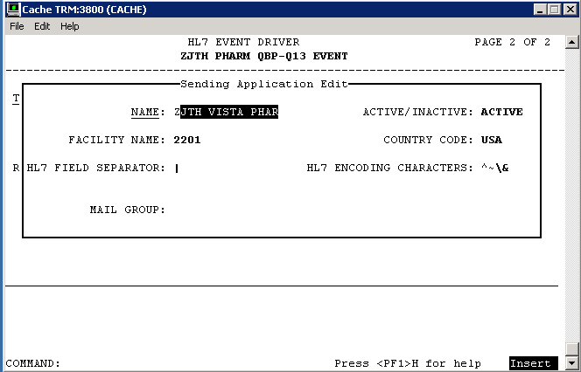

Figure : Example of Configuration of a Protocol to handle QBP-Q13 Events

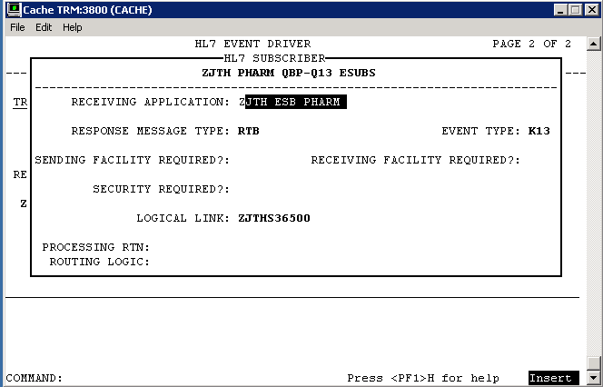

Figure : Example of Configuration of a Protocol to handle QBP-Q13 Events

### HL7 Sender and Receiver Applications

Sender and Receiver HL7 applications will be configured in VistA to fill MSH-3, 4, 5 and 6 fields. The Sending Application Facility Name is used to convey the site number of the VistA. The following is an example configuration of applications used in the protocols above:

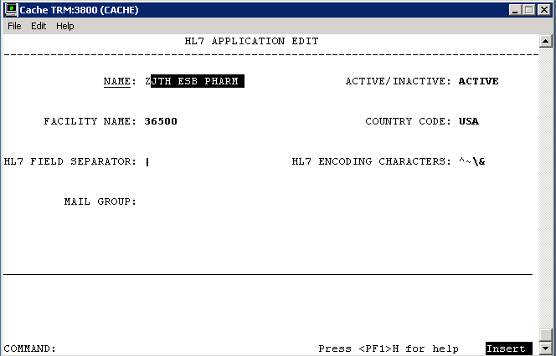

Figure : Receiving HL7 Application Configuration

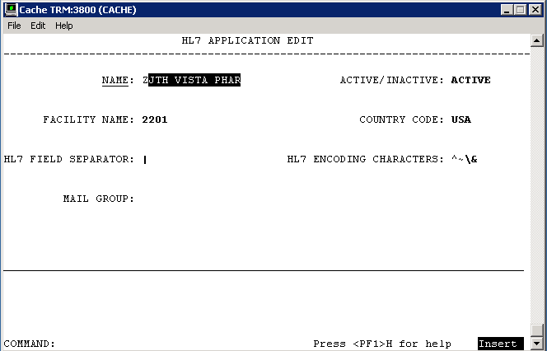

Figure : Sending HL7 Application Configuration

### Sender and Receiver Logical Links

A client logical link will be configured in VistA with the IP and Port of the EMI. Additionally, a server or listening logical link will be added. HL7 messaging will be used to exchange requests between the initiating VistA and the EMI. The following is an example configuration of logical links used in the applications above:

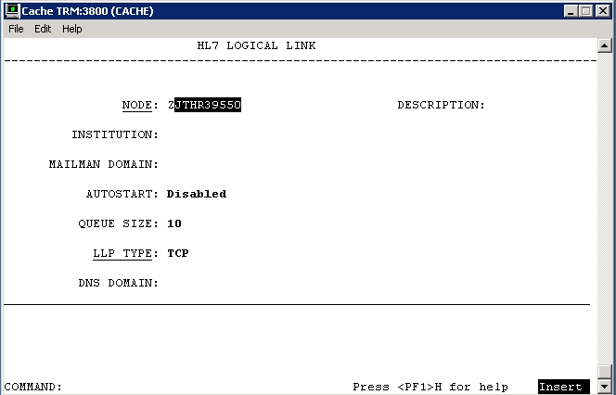

Figure : Example of Configuration of Logical Links

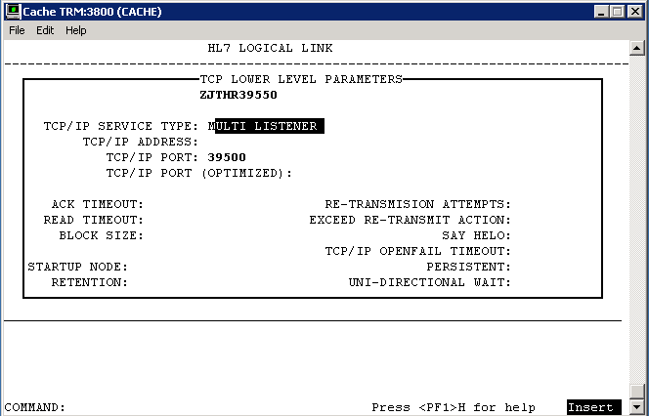

Figure : Example of Configuration of Logical Links

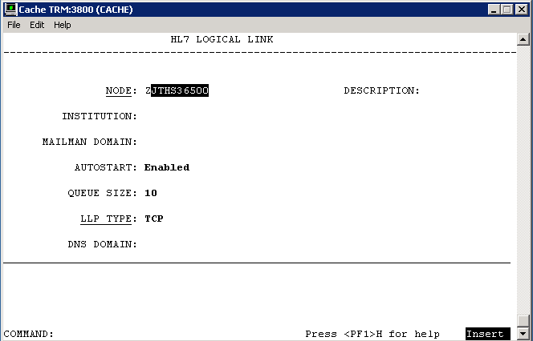

Figure : Example of Configuration of Logical Links

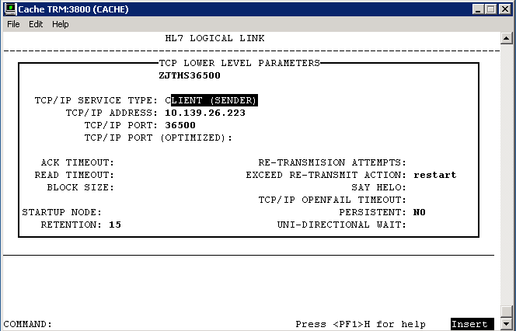

Figure : Example of Configuration of Logical Links

Table 53: HL7 Application Parameter (Instructions)

| HL7 Application Parameter | Instructions |
| --- | --- |
| **HL7 Application Parameter Name** | List the HL7 Application Parameter affected or needed by the changes being designed. |
| **Enhancement Category** | Check the appropriate box: New, Modify, Delete, or No Change. |
| **Application Status** | Check the appropriate box in the applicable column for Current and Modified |
| **Facility Name** | List the current and modified value in the appropriate column. |
| **Country Code** | List the current and modified value in the appropriate column. |
| **HL7 Field Separator** | List the current and modified value in the appropriate column. |
| **HL7 Encoding Characters** | List the current and modified value in the appropriate column. |
| **Mail Group** | List the current and modified value in the appropriate column. |

Table 54: HL7 Application Parameter

| HL7 Application Parameter Name | Description |
| --- | --- |

|  |  |  |  |  |
| --- | --- | --- | --- | --- |
| **Enhancement Category** | New | Modify | Delete | No Change |

|  |  |  |  |  |
| --- | --- | --- | --- | --- |
| **Application Status** | Active | Inactive | Active | Inactive |

| Enhancement Category | Current | Modified |
| --- | --- | --- |
| **Facility Name** |  |  |
| **Country Code** |  |  |
| **HL7 Field Separator** |  |  |
| **HL7 Encoding Characters** |  |  |
| **Mail Group** |  |  |

##### HL7 Logical Link

Table 56: HL7 Logical Link

| HL7 Logical Link | Description |
| --- | --- |
| **HL7 Logical Link Parameter Name** | **ZJTHR39550** - NAME CHANGE REQUIRED** |

|  |  |  |  |  |
| --- | --- | --- | --- | --- |
| **Enhancement Category** | **New** | **Modify** | **Delete** | **No Change** |

| Enhancement Category | Current | Modified |
| --- | --- | --- |
| **Node** | **N/A** | **ALL??** |
| **Institution** | **N/A** | **N/A** |
| **Domain** | **N/A** | **N/A** |
| **Autostart** | **N/A** | **Disabled** |
| **Queue Size** | **N/A** | **10** |
| **LLP Type** | **N/A** | **TCP** |

| HL7 Logical Link | Description |
| --- | --- |
| **HL7 Logical Link Parameter Name** | **ZJTHS36500** - NAME CHANGE REQUIRED** |

|  |  |  |  |  |
| --- | --- | --- | --- | --- |
| **Enhancement Category** | **New** | **Modify** | **Delete** | **No Change** |

| Enhancement Category | Current | Modified |
| --- | --- | --- |
| **Node** | **N/A** | **ALL??** |
| **Institution** | **N/A** | **N/A** |
| **Domain** | **N/A** | **N/A** |
| **Autostart** | **N/A** | **Enabled** |
| **Queue Size** | **N/A** | **10** |
| **LLP Type** | **N/A** | **TCP** |

##### COTS Interface

Not applicable.

## Network Detailed Design

Provide enough detailed information about the communication requirements to build and/or procure the communication components for the system. This section should provide sufficient detail to support the procurement of hardware for the system installation. Include the following information in the form of detailed designs (as appropriate):

* Details of servers and clients to be included on each area network
* Specifications for bus timing requirements and bus control
* Format(s) for data being exchanged between components
* Diagrams showing connectivity between components, data flow (if applicable), and distances between components
* LAN topology.

## Security and Privacy

### Security

#### Secure Sockets Layer (SSL)

The OneVA Pharmacy architecture does not use SSL to transport HL7 from VistA to/from the Pharmacy Manager. The Pharmacy Manager uses the HAPI (HL7 application programming interface; pronounced "happy") open-source, object-oriented HL7 2.x parser for Java which is capable of sending and receiving HL7 over SSL. The use of SSL is achievable with minor modifications to the Pharmacy Manager. The scope and complexity of the changes required to VistA to support HL7 over SSL are unknown.

The HTTP communication between the Pharmacy Manager and the RESTful web services, among other systems, can use HTTP secure sockets or HTTPS. Configuration changes to the Java application server are needed. Switching a Java application server from HTTP to HTTPS is easily accomplished but outside the scope of this document. Once HTTPS switch over is completed, the configuration endpoint URLs in the Pharmacy Manager configuration will need updating from http:// to https://; see Installation Manual for details.

#### Authentication and Authorization

The RESTful web services, by default, use a security filter that transforms VistA login credentials into JEE-compatible login credentials. The web services use the HTTP BASIC authentication username and password as access and verify codes, respectively, and make a call to the MUMPS CHECKAV^XUSRB function for validation and retrieval of the user identifier (DUZ) to be used in subsequent calls.

#### Remote Prescription Locking

Before any action is taken on a remote prescription, the prescription is locked. The lock only remains long enough for the routines to file the data, which is generally only a few milliseconds. This prevents a ‘remote’ refill or partial fill from occurring in the event that a user at the originating site is taking action on the same patient’s prescription.

### Privacy

Not applicable.

## Service Oriented Architecture / ESS Detailed Design

This section provides details of provided and consumed services as follows:

* Consumed Services: Provide link to Service Description Document for each consumed service.
* Provided Services: Give service design for each provided service.

The information you provide here will be used to upload to the ESS Registry and Repository. At some point in the near future, we do not expect these SOA artifacts such as SLA, Service Description, etc. to be static documents. They will be dynamically generated from the ESS Registry and Repository tool in the form of reports. Any application and service integration design is also documented here.

A list of currently available Enterprise Shared Services is available here: <insert link to ESS list>

### Service Description for <Consumed Service Name>

Provide link to Service Description document for the consumed service. This section will repeat for each consumed service. The Service Description includes Service Interface and Service Level Definition (SLD) to address anticipated capacity requirements.

### Service Design for <Provided Service Name>

This section should describe the detailed service design for each ESS and SOA service needed to obtain an intended result. The Service Design includes Service Interface and Service Level Definition (SLD) to address anticipated capacity requirements.

This section will repeat for each **provided** service.

#### Introduction

##### Purpose and Scope of Service

This service was described at a high level in the charter document. Please refer to it here via a link.

##### Links to Other Documents

Provide links to other documents created for this service so far in the SOA lifecycle. At a minimum, provide links to:

* Service Charter
* Service Roadmap
* Service Description

#### Service Details

##### Service Identification

This section will be written as a table to provide a quick reference to the service's what, where, why and how - cheat sheet.

| Service Attribute | Value |
| --- | --- |
| Name and Alias (if any) | Name of the service and other names for the service, which might be used by someone searching for this service. Please follow ESS naming standards. |
| Overview | Brief textual overview of the service. |
| Version | Version number of the service being described here |
| Latest Status | This field shows the latest status for the above referenced version of this service! The status of a service shows the progress of the service from initiation through development, deployment, and eventual retirement. The status also has a status date associated with the status - and we will be using the latest one here in this document. Valid values include: Inception, Design, Provisioning, Certification / Testing, Operation, Deprecated, Retired, Rejected - Owner has decided not to develop the service. |
| Service Type | Used to define applicable architecture patterns. Examples (from Open Group):  • Interaction  • Process  • Information  • Partner  • Business Application  • Access  • Service Connectivity |
| Architecture Layer | Referred to as class in VA Service template. Used to define applicable architecture patterns and relationships to governing bodies. Examples:  • Solution  • Process  • Information  • Utility  • Underlying |
| Business Domain | Business Vertical or Business Division where this service belongs. |
| Service Domain | The service or technical domain that the service belongs to. Can be used to establish the namespace. |
| Business Organization and Owner | Person who approves this service & any changes. Include email. |
| Technical Organization and Owner | Person responsible for provisioning (specifying, acquiring certifying) this service. Include email. |
| Development Organization and Owner | Person who is responsible for the development processes and activities for this service. Include email. |
| Support Organization and Owner | Person who is responsible for the support of this service while in production. Include email. |
| Target Consumer Organization(s) and Owner(s) | Organizations and/or developers roles that service is intended for. |

##### Service Versions

|  |  |  |
| --- | --- | --- |
| Version Numbers | Current Status of Version | A Brief Description of the change implemented in that version |
| This version | Being Designed |  |
| Example: version 2 | Example: In production. Will be retired with this release. | Example: This release added the ability to look up a person by address.  Provide a link to each version of the service. |
| Example: version 1 | Example: Retired. | Example: This release provided the base minimum functionality to look up a person by name.  Provide a link to each version of the service. |

##### Summary of Design and Platform Details

###### SOA Pattern(s) Implemented

Name of the SOA pattern implemented – for instance, this may be a Pub/Sub model. Just a name and reference to the document or book with the pattern is sufficient for popular patterns or VA's own patterns. If you are using some esoteric pattern, more details will help.

###### COTS Platform vendor names and versions for hosting platform

Example, TIBCO.

#### Dependencies

The Dependency Model identifies other services, systems, databases, etc. that [Service Name] is dependent upon or interacts with to perform its function.

This section should clearly identify all sources and external systems that are accessed by this service to fulfill the service consumers’ request. This section should include diagrams to show as much detail as necessary to inform the developer. Provide a context diagram for the service.

Note: Here our primary audience includes the providers of the service. So this document in general will emphasize system components and sub-systems as much as external interactions.

#### Service Design Details

The next sub-section on Interface Technical Specs **could be** just a copy from the corresponding sub-section in Interface section in the Service Description Document. Here, you could provide more detail necessary for building this service but **the interface spec needs to be consistent between this document and the Service Description Document**. This section contains all information necessary to fully describe an interface published by this service...

##### Interface Technical Specs

The technical specification allows developers of service consumers to locate and discover the service for run time consumption.

###### Service Invocation Type

Such as: SOAP over HTTP, REST.

###### Service Interface Type

Such as: WSDL via Web Service 2.0

###### Service Name

Technical Service Name. Comply with ESS naming standards.

###### Interface

Link to WSDL or other interface document.

###### End Points

Provide if known! Calls that can be made into the service. Can be referenced to the WSDL or can be in a separate table.

###### Operations or Methods

In the table below, the technical names of the operations, inputs and outputs are used. Inputs and outputs, if parameters, must have a data type.

Non-primitive data types must be defined in the Service Information Model section.

This table could be generated automatically from the WSDL content or its equivalent.

Style can take any of these values: Parameters or Document; and One-way or Request-response or Solicit-response or Notification.

Use a separate column for the operation purpose if you wish.

You might use abbreviations in the Faults column and explain the abbreviations used below the table. For example, NF = Not Found, MI = Missing Input.

|  |  |  |  |  |  |
| --- | --- | --- | --- | --- | --- |
| Operation Name | Inputs | Outputs | Transactional Qualities if relevant (Updating?, Atomic?, Can participate in transaction?) | Pre and Post Conditions | Exception (s) |
|  |  |  |  |  |  |
|  |  |  |  |  |  |

Provide a link to the Service Information model so that the consumer of your system knows the schema for the input and output parameters.

###### Message Schemas

Provide definitions or links to definitions of the message(s) related to the service operations. These may be dependent on the implementation style and protocol binding of the interface.

##### Information Model

Even though this section looks similar to the corresponding section 3.2 in Service Description, remember that the primary objective here is to facilitate construction and to gain approvals from governing bodies. So you will provide more of a “white box” view of the design here to help your developers code the service.

###### Class Diagram and Description of Entities Involved

Map out all entities involved in the service: input, output, exceptions, entities manipulated in persistent media/DBs, intermediate entities created in memory etc.

###### Mappings from ELDM to Standards Based Schemas

Provide mappings from your native schema to any standards based schemas your service will use to communicate outside. For instance, if you are using HL7 based messages then you will show how data is converted from your native schema to HL7.

##### Behavior Model (AKA Use Case Realization)

The Behavior Model defines the actions and processes supported by the service. Actions and methods represented in the use cases and sequence diagrams shown below are further defined by the operation contracts and the message payloads.

###### Use Cases (Use Case Model)

Describe how this service fits into the larger use case model of the consumer. You may need multiple models for multiple consumers. Focus is **not** on the internal workings of the new service instead of the calls made from external consumers. Just a summary or the Use Case Diagram may be sufficient. List the alternative and exception flows. Reference the detailed design documents via a URL.

###### Interaction Diagrams

Cut and paste screen shot from RSA or similar tool or provide link to the model. Provide description to help developers build your service. The interaction diagrams should depict external interactions and internal sequences of calls between internal components. The sequence diagram should cut through all layers to show the main, alternate and exception flows.

#### Gap Analysis

Provide a Gap Analysis (Reference) to demonstrate compliance of this service with various standards, policies, guidelines and laws. The Gap Analysis may take the form of a matrix as shown in the sample below. This will help the governance boards expedite your request.

| Design Elements🡪  Policies / SLD elements etc.↓ | Design  Element A | Design  Element B | Design  Element C | Comment for non-conformance |
| --- | --- | --- | --- | --- |
| Policy X | Match |  |  |  |
| Policy Y |  | Partial |  |  |
| Policy Z |  |  |  | Commercial encryption server in prod will have to address this policy. |
| Policy A |  |  |  | Compliance with this policy not required until next year. |
| New / Additional Features |  |  | New element minimizes manual intervention |  |

##### Variances from Enterprise Target Architecture

This list of “variances” will become a submission to the ESS dispensation process.

##### Variances from SLDs

This list of “variances” will become a submission to the ESS dispensation process.

##### Variances from Standards and Policies

This list of “variances” will become a submission to the ESS dispensation process.

##### Justification for Exceptions and Mitigation

This section will list out any non-functional and functional requirements that are not being met. The non-conformance may be in violation of elements of SLDs, enterprise architecture (TRM Technology Reference Model), privacy policies or guidelines. For each exception provide:

1. Reasons for non-conformance (cost, time, technology, etc.)
2. Mitigating actions taken to reduce the impact of non-conformance
3. Plan (roadmap) to come back into conformance

This list can grow depending on what the Review bodies may ask for.

# External System Interface Design

This section details interfaces external to system, that are NOT services (ESS/SOA). Typically, these may include, RPCs, Flat Data Files etc.

External systems are systems that are not within the scope of the system under development, regardless of whether the other systems are managed by the vendor or its client.

In this section, describe the interface(s) between the system under development (i.e., the system that is the subject of this SDD) and external systems and/or subsystem(s).

It is best to illustrate these sections with annotated diagrams to clearly identify the various elements of the interfaces.

## Interface Architecture

Describe the interface(s) between the system being designed and other systems. Include the interface architecture(s) being implemented, such as wide area networks, gateways, etc. Provide diagrams showing the communications path(s) between this system and other systems.

## Interface Detailed Design

HL7 v2.5.1 messaging is used to communicate between VistA and the eMI ESB. The following codes are provided for reference.

## Acknowledgement Codes

Table : Acknowledgement Codes

| Code | Status | Description |
| --- | --- | --- |
| AA | Application Accept | Requested action or operation was successfully performed |
| AR | Application Reject | Requested action or operation failed due to service errors |
| AE | Application Error | Requested action or operation failed due to HL7 message or semantic errors |

## Order Control Codes

Table : Order Control Codes

| Code | Status |
| --- | --- |
| RF | Refill order request |
| PF | Partial fill order request* |
| AF | Order refill authorization request approved |
| DF | Order refill authorization request denied |
| FU | Order refilled unsolicited at patient’s request |
| OF | Order refilled as requested by placer system |

*PF is not an HL7 standard code

## Remote Prescription Query Transaction

The remote prescription query request is a QBP^Q13 message type and the response is a KTB^K13 message type. The “Chapter” reference below refers to the HL7 Standard Version 2.5.1 documentation.

### Remote Prescription Query Request

The QBP^Q13 request is defined in Table 4. The implementation will ignore RDF and DSC segments and additionally, any segment not shown below is ignored.

Table : Remote Prescription Query Request

| QBP^Q13 | QBP Message | Chapter |
| --- | --- | --- |
| MSH | Message Header Segment | 2.15.9 |
| QPD | Query Parameter Definition | 5.5.4 |
| PID | Patient Identification | 3.4.2 |
| [RDF] | Table Row Definition Segment | 5.5.6.6 |
| RCP | Response Control Parameter | 5.5.6 |
| [DSC] | Continuation Pointer | 2.15.4 |

Table : QPD Field Description and Commentary

| Field Seq | Field Name | HL7 Data Type | Description |
| --- | --- | --- | --- |
| 1 | Message Query Name | CE | Must be Q13^Active Prescriptions^HL70471 |
| 2 | Query Tag | ST | Unique to each query message instance |

Table : PID Field Description and Commentary

| Field Seq | Field Name | HL7 Data Type | Description |
| --- | --- | --- | --- |
| 1 |  |  | Ignored |
| 2 |  |  | Ignored |
| 3 | MRN | CX | One or more patient identifiers may be sent. Each site provided and configured will be queried for prescriptions. |
| n |  |  | Ignored |

RCP Field Description and Commentary

Table : RCP Field Description and Commentary

| Field Seq | Field Name | HL7 Data Type | Description |
| --- | --- | --- | --- |
| 1 | Query Priority | ST | Must be “I” for Immediate |
| n |  |  | Ignored |

### Sample QBP^Q13 Request

**MSH**|^~\&|ZJTH VISTA PHARM|2101|ZJTH MIRTH PHARM|36500|20140102125951-0500||QBP^Q13|301|T|2.5.1|||NE|AL|USA

**QPD**|Q13^Active Prescriptions^HL70471|512123456

**PID**|||1666000286V397907^^^USVHA^NI^200M~100232^^^USVHA^PI^500~100445^^^USVHA^PI^612~100232^^^USVHA^PI^2204~100232^^^USVHA^PI^2202

RCP|I

### Remote Prescription Query Response

The KTB^K13 response is defined as follows.

Table : Remote Prescription Query Response

| KTB^Q13 | QBP Message | Chapter |
| --- | --- | --- |
| MSH | Message Header Segment | 2.15.9 |
| MSA | Message Acknowledgement | 2.15.8 |
| [ERR] | Error | 2.15.5 |
| QAK | Query Acknowledgement | 5.5.2 |
| ZAK | Z-Segment | Defined below |
| QPD | Query Definition Segment | 5.5.4 |
| RDF | Table Row Definition Segment | 5.5.6.6 |
| [{RDT}] | Table Row Data Segment | 5.5.6 |

An ERR segment will be sent when MSA.1 acknowledgement code is AR or AE.

Table : RCP Field Description and Commentary

| Field Seq | Field Name | HL7 Data Type | Description |
| --- | --- | --- | --- |
| 1 | Site Number | ST | VistA site number |
| 2 | Count returned | NM | Count of rows returned from VistA site |
| 3 | Success indicator | NM | 1 – success  0 – unknown error  -1 – connection failure  -2 – response timeout |

The RDF segment and data in the RDT segment contains the following fields:

* Site Number
* Rx Number
* Drug Name
* Quantity
* Refills
* Days Supply
* Expiration Date
* Issue Date
* Stop Date
* Last Fill
* Sig
* Detail

### Sample KTB^K13 Response

**MSH**|^~\&|ZJTH MIRTH PHARM|36500|ZJTH VISTA PHARM|2101|20140109155138.281-0500||ACK^Q13^ACK|19|T|2.5.1

**MSA**|AA|50022643

**QAK**|512123456|OK|Q13^Active Prescriptions^HL70471|2

**ZAK**|2302|3|1|Success

**ZAK**|2303|0|-1|Connection timeout.

**RDF**|12|Site Number~Rx Number~Drug Name~Quantity~Refills~Days Supply~Expiration Date~Issue Date~Stop Date~Last Fill Date~Sig~Detail

**RDT**|2302|501109|NAPROXEN 250MG TAB|60|11|30|20150517.000000|20140516.000000|20150517.000000|20140516.000000|TAKE ONE TABLET BY MOUTH TWICE A DAY|NAPROXEN 250MG TAB Qty: 60 for 30 days

**RDT**|2302|501110|RANITIDINE HCL 25MG EFFER TAB|60|6|30|20150517.000000|20140516.000000|20150517.000000|20140516.000000|DISSOLVE 1 MOUTH TWICE A DAY|RANITIDINE HCL 25MG EFFER TAB Qty: 60 for 30 days

**RDT**|2302|501123|ACETAMINOPHEN 325MG TAB|240|5|30|20150726.000000|20140725.000000|20150726.000000|20140814.000000|TAKE TWO TABLETS BY MOUTH EVERY 6 HOURS AS NEEDED |ACETAMINOPHEN 325MG TAB Qty: 240 for 30 days

## Remote Prescription Dispense Transaction

The remote prescription refill dispense request is a RDS^O13 message type and the response is a RRD^O14 message type. This message is used to convey that the requesting system wishes to lock the remote order. The “Chapter” reference below refers to the HL7 Standard Version 2.5.1 documentation.

### Remote Description Dispense Request

The RDS^O13 request is defined in **Table 10** and any segment not shown is ignored.

Table : Remote Description Dispense Request

| RDS^O13 | RDS Message | Chapter |
| --- | --- | --- |
| MSH | Message Header Segment | 2.15.9 |
| PID | Patient Identification | 3.4.2 |
| ORC | Common Order | 4.5.1 |
| RXO | Pharmacy/Treatment Prescription Order | 4.14.1 |

Table : PID Field Description and Commentary

| Field Seq | Field Name | HL7 Data Type | Description |
| --- | --- | --- | --- |
| 1 |  |  | Ignored |
| 2 |  |  | Ignored |
| 3 | MRN | CX | One or more patient identifiers may be sent. Each site provided and configured will be queried for prescriptions. |
| n |  |  | Ignored |

Table : ORC Field Description and Commentary

| Field Seq | Field Name | HL7 Data Type | Description |
| --- | --- | --- | --- |
| 1 | Order Control | ID | **Error! Reference source not found.** **Error! Reference source not found.** |
| 2 | Placer Order Number | EI | The originating order prescription number |
| 3 |  |  | Ignored |
| 4 |  |  | Ignored |
| 5 |  |  | Ignored |
| 6 |  |  | Ignored |
| 7 |  |  | Ignored |
| 8 |  |  | Ignored |
| 9 | Date/Time Transaction | TS | Date/Time of request |
| 10 | Entered By | XCN | Provides pharmacist identifier and name |
| 11 |  |  | Ignored |
| 12 |  |  | Ignored |
| 13 | Enterer’s Location | PL | Provides pharmacist’s site number |
| 14 | Call Back Phone Number | XTN | Provides pharmacist’s callback phone number |

Table : RXO Field Description and Commentary

| Field Seq | Field Name | HL7 Data Type | Description |
| --- | --- | --- | --- |
| 1 |  |  | Ignored |
| 2 |  |  | Ignored |
| 3 |  |  | Ignored |
| 4 |  |  | Ignored |
| 5 |  |  | Ignored |
| 6 |  |  | Ignored |
| 7 |  |  | Ignored |
| 8 | Deliver-To Location | LA1 | Provides (W)indow, (M)ail and requesting site number |

Sample RDS^O13 Refill Request

**MSH**|^~\&|ZJTH VISTA PHARM|2201|ZJTH ESB PHARM|36500|20140415110833-0500||RDS^O13|50024242|T|2.5.1|||NE|AL|USA

**PID**|||1666000286V397907^^^USVHA^NI^200M~100232^^^USVHA^PI^2202

**ORC**|RF|500974^2202|||||||20140415|1^PROGRAMMER^ONE|||^^^500|6655544

**RXO**||||||||W^^^2201

Sample RDS^O13 Partial Fill Request

**MSH**|^~\&|ZJTH VISTA PHARM|2201|ZJTH ESB PHARM|36500|20140716081903-0500||RDS^O13|50030627|T|2.5.1|||NE|AL|USA

**PID**|||1111000440V046182^^^USVHA^NI^200M~101016^^^USVHA^PI^2202

**ORC**|PF|501145^2202|||||||20140710|10000000225^TERRELL^GAIL|||^^^500|502-233-2355

**RXO**|1|10||||||W^^^500|||10

**NTE**|1|L|test

### Remote Description Dispense Response

The RRD^O14 response is defined as follows.

Table : Remote Description Dispense Response

| RRD^O14 | RRD Message | Chapter |
| --- | --- | --- |
| MSH | Message Header Segment | 2.15.9 |
| MSA | Message Acknowledgement | 2.15.8 |
| [ERR] | Error | 2.15.5 |
| ORC | Common Order | 4.5.1 |
| RXD | Pharmacy/Treatment Dispense Segment | 4.14.1 |

An ERR segment will be sent when MSA.1 acknowledgement code is AR or AE.

Table : RXD Field Description and Commentary

| Field Seq | Field Name | HL7 Data Type | Description |
| --- | --- | --- | --- |
| 1 |  |  | Ignored |
| 2 | Dispense/Give Code | CE | National Drug Code (NDC) |
| 3 | Date/Time Dispensed | TS |  |
| 4 | Actual Dispense Units | CE |  |
| 5 |  |  | Ignored |
| 6 |  |  | Ignored |
| 7 | Prescription Number | ST | Format: PSOIEN::REFIEN |
| 8 | Number of Refills Remaining | NM |  |
| 9 |  |  | Ignored |
| 10 | Dispensing Provider | XCN |  |
| 11 |  |  |  |
| 12 | Total Daily Dose | CQ | Days Supply |

Sample RRD^O14 Refill Response

MSH|^~\&|ZJTH ESB PHARM|36500|ZJTH VISTA PHARM|2302|20140723091250.151-0400||ACK^O13^ACK|12173|T|2.5.1

MSA|AR|50024459

PID|||1111000449V272697^^^USVHA^NI^200M~101044^^^USVHA^PI^2303

ORC|UF|501109^2303|||||||20140723|10000000225^TERRELL^GAIL|||^^^500|490-444-5555

Sample RRD^O14 Partial Fill Response

**MSH**|^~\&|ZJTH ESB PHARM|36500|ZJTH VISTA PHARM|2201|20140716081939.298-0400||ACK^O13^ACK|10412|T|2.5.1

**MSA**|AA|50030627

**NTE**|1||Partial complete for RX #501145.

**PID**|||1111000440V046182^^^USVHA^NI^200M~101016^^^USVHA^PI^2202

**ORC**|OF|501145^2202|||||||20140710|10000000225^TERRELL^GAIL|||^^^500|502-233-2355

**RXD**|1|^NAPROXEN 125MG/5ML SUSP^NDC|20140710000000-0400|10|||404366::1|||^RADIOLOGIST^ONE^^^^^^^^^^^^^2&VEHU SITE^^^20140717162300-0400||10

# Human-Machine Interface

The OneVA Pharmacy *Implementation* project will utilize existing Vista functionality to the fullest extent possible.

## Interface Design Rules

Identify conventions and standards for designing the GUI.

## Inputs

Identify the input media used by the user (i.e., operator) for providing information to the system, such as data entry screens, optical character readers, bar scanners, etc.

Identify the messages associated with operator inputs, including the following:

* Form(s) if the input data is keyed or scanned for data entry
* Access restrictions
* Security considerations.

## Outputs

Describe the system output design relative to the user. System outputs include reports, data display screens, query results, etc.

Identify the following, if appropriate:

* Access restrictions or security considerations
* Description of the purpose of the output
* Report requirements, including frequency of periodic reports
* Screen contents. (Provide a graphic representation of each layout. Define all data elements associated with the layout).

## Navigation Hierarchy

Provide a diagram of the navigation hierarchy that shows how a user moves through the GUI.

### Prescription Display

PSO LM BACKDOOR ORDERS will be modified to display remote Rx’s in the same screen where the local Rx’s are displayed for a patient. The remote prescriptions will occur after any local Rx’s and will have a section header ‘-----SITE NAME (SITE NUMBER)----‘delineation. Leveraging existing functionality means less training, and more immediate familiarity with the process.

Once the user selects to ‘Refill’ or ‘Partially Refill’, a prompt will display to enter the required information for sending a request to the ‘originating’ system, so that the refill or partial fill may be completed and the Rx data updated.

The ‘Select Order’ function within PSO LM BACKDOOR ORDERS will be modified to differentiate between the local and remote orders and pull from the remote order ^XTMP array when needed.

Once the user has selected the order, a new option will be available to either ‘refill remote order’ or ‘partial refill remote order’. The updates to the data will occur on the system of origin. Additional fields will be added to the Prescription file (#52) but have yet to be fully determined. The fields will include, remote pharmacist name, remote pharmacist phone number, and remote filling site.

A new local file will be added to hold the information about the remote prescription that has been filled. This file will contain information about the site, Rx number, pharmacist who filled the Rx, and the date the prescription was filled in the ‘local’ system. This file will be used for reporting and tracking purposes.

Additional options may be made available for reprinting of labels.

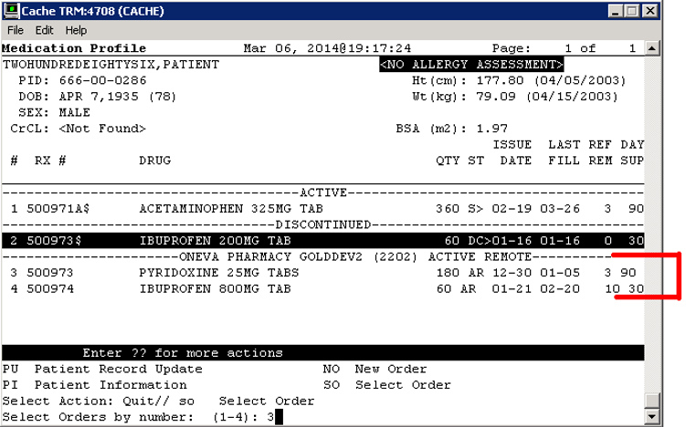

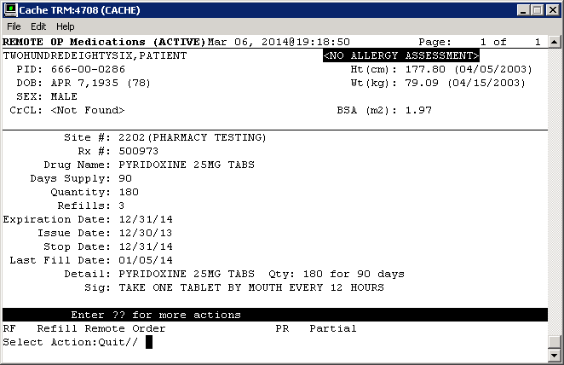

# Attachment A – Approval Signatures

This section is used to document the approval of the OneVA Pharmacy Implementation System Design Document during the Formal Review. The review should be ideally conducted face to face where signatures can be obtained ‘live’ during the review however the following forms of approval are acceptable:

1. Physical signatures obtained face to face or via fax

2. Digital signatures tied cryptographically to the signer

3. /es/ in the signature block provided that a separate digitally signed e-mail indicating the signer’s approval is provided and kept with the document

The following members of the governing Integrated Project Team (IPT) are required to sign. Please annotate signature blocks accordingly.

REVIEW DATE:

SCRIBE:

Signed:

______________________________________________________________________________

Joshua Patterson Date

Integrated Project Team (IPT) Chair

______________________________________________________________________________

Michael Valentino Date

Business Sponsor

______________________________________________________________________________

Cecelia Wray Date

Project Manager

1. Additional Information

Attach any addition information that supplements the design specification.

* 1. Identification of Technology and Standards

Reference materials includes the following:

* IEEE 2016-2009, Systems Design / Software Design Descriptions – <http://standards.ieee.org/findstds/standard/1016-2009.html>
* HL7 Messaging Standard v2.5.1 - <http://www.hl7.org/implement/standards/product_brief.cfm?product_id=144>
* VA118-13-R-0445, B.3 Performance Work Statement issued 2013-07-26
* Medical Domain Web Services (MDWS) documentation - <http://va.gov/vdl/application.asp?appid=192>
* HL7 (VistA Messaging) documentation - <http://va.gov/vdl/application.asp?appid=8>
* My HealtheVet documentation - <http://va.gov/vdl/application.asp?appid=153>
  1. Constraining Policies, Directives and Procedures

Not applicable.

* 1. Requirements Traceability Matrix

Include an RTM that traces modules and data structures to the software requirements. A reference to the location of the RTM is also acceptable.

* 1. Packaging and Installation

Outline any special considerations for software packaging and installation.

* 1. Design Metrics

Describe all metrics to be used during the design activity.